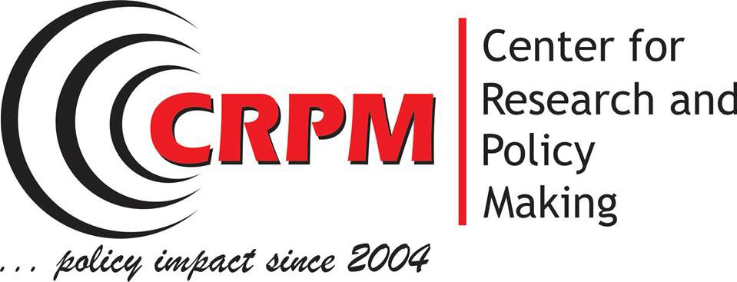

Annual Report 2019

This document summarizes the activities undertaken by the Centre for Research and Policy Making in the course of implementation of its 2019 work program. It reports on outputs and impact the CRPM work has on policy making in Macedonia and South East Europe.

Table of Contents
I. General Report 4
1. Academic activity and conferences of CRPM members 4
XXIX Economic Forum, Krynica–Zdrój, Poland, SEPTEMBER 3-5, 2019 4
ECPR 13th General Conference, University of Wrocław, 4 – 7 September 2019 5
Economic forum on the 70 years of development and building of a community with a shared future for menkind – Shanghai 6-7th November, 2019 5
Western Balkans Summit in Poznań: strengthening links within the region and with the EU, 4-6 July, 2019 6
EU preventing and countering violent extremism training in WB, Sarajevo October 2019 6
Freja Forum 2019, Skopje 8-10 November 7
1.2. Academic publishing 7
2. CRPM policy research and analysis work 8
2.1. Macedonian politics 8
School of Public Policy IMother TheresaI 8
EU POLICY BREAKFAST 9
The impact of Europeanization on the Balkan countries and their potential shift from the periphery toward the center 10
2.2. Labor 11
The Adaptation of Industrial Relations towards New Forms of Work 11
Analysis of the legislation curbing informal economy 12
Service needs assessment for the Union of Independent and Autonomous Trade Unions of Macedonia 13
Increasing employment opportunities for seasonal workers 13
2.3. Education 14
Educate to Prevent - Strengthening Front-line School Workers and Parents to Build Youth Resilience to Violent Extremism 14
“Development of a municipal preventive system / referral mechanism for VERLT (activity 5) and “Strengthening Social Cohesion in the Country (Activity 21 and 22) 15
Safe Internet – Resilient Youth 15
2.4. Gender 16
Advocacy and expert level dialogue with Government and Parliament to amend existing legislation in the field of genderbasedviolence and gender-based discrimination, in line with international standards, human rights mechanisms recommendations (UPR, CEDAW, CAT, CERD, CCPR, CESCR), EU Directives and Istanbul Convention 16
Gender Budget Watchdog Network 17
Implementing Norms, Changing Minds – Pre and Post Survey 18
3.6 Sustainable development 19
Regional cooperation and competence development of parliamentarians of South –East Europe on energy efficiency, climate topics and sustainable urban mobility 20
4. CRPM events 21
World Forum of Democracy 21
NATO SPS 21
5. Outputs/ Results: 22
5.1. Books 22
5.2. Policy briefs 23
5.3. Policy Studies 23
Needs analysis on criminal code compliance with the Istanbul Convention in the Republic of North Macedonia 23
5.4 Policy initiatives 23
5.5. Guides 23
II. Financial report 2019 23
Center for Research and Policy Making – CRPM Skopje 23
Financial report 23

I. General Report
2019: Achieving objectives startegic objectives set in CRPM 5 year plan
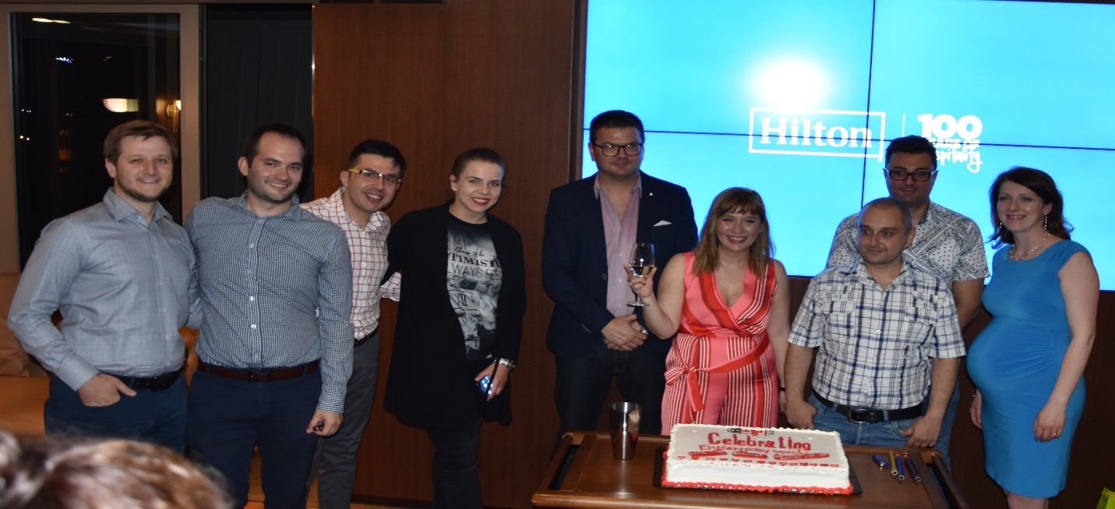
This year we celebrated 15 years of policy impact and marked it with a new milestone – took leadership in a program that includes 7 countries in the region: Albania, Bosnia and Herzegovina, Montenegro, Macedonia, Moldova, Kosovo and Serbia; and undertaken research that resulted with a policy study that covers development of 9 countries in SEE in the framework of their European integration. With this the ambition that we have taken with our strategy for development five years ago to become leading think tank in the region is slowly being achivied. Over the years CRPM incresed the activities mostly in neighboring Albania and Kosovo, and through networking collaborated on projects implemented in other countries of the region. Hence in 2019 we have embarked to work as lead organization on two portfolios gender mainstreaming of policies and budgets; and European integration.
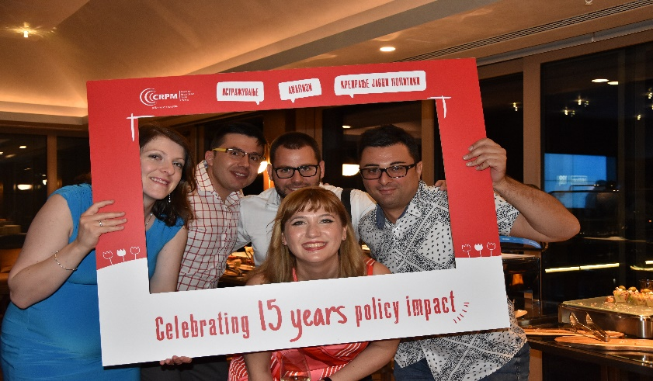
In 2019 the team managed to maintain the partnership contracts with CoE, OSCE, GIZ, UNWomen and the EU. In addition we have entered in partnership with two new billateral donors: Austrian Development Agency and China CEE Institute. During the EU council Presidency of Romania and Poland in cooperation with two Embassies of the respected countries we have organized events and invigorated the debate on hybrid threats and the new EU methodology for enlargement. Finally, in 2019 we worked with the multilateral actors, NATO and the World Bank. CRPM’s main funding partners remains the European Union, but we are steadily achieving the second goal in our five year strategy which is diversified funding.
On personal note, 2019 was also a productive year. CRPM’s Ivan, Ana, Aleksandar and Kristijan were expectin babies. So with new enthusiasm, ideas and enforcement will welcome year 2020.

1. Academic activity and conferences of CRPM members

XXIX Economic Forum, Krynica–Zdrój, Poland, SEPTEMBER 3-5, 2019
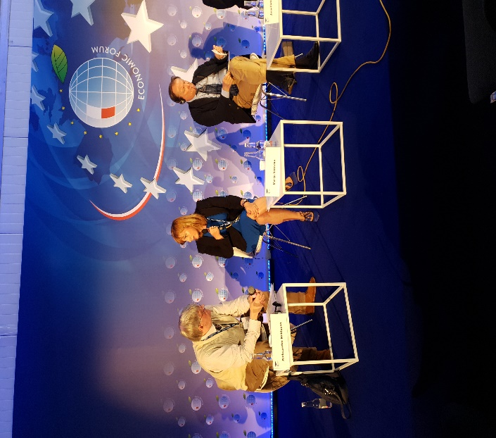
Marija Risteska, Founder and Executive Director of the Center for Research and Policy Making is the first civil society leader from Macedonia that spoke at the Economic Krynica Forum. Centre for research and policy making was co-organizer of the panel titled: “Will the World Order Turn into Global Chaos?” chaired by Maurizio Caprara, Senior Foreign Affairs Commentator at Italy’s Corriere della Sera. Panellists included Dirk Niebel; Karel Schwarzenberg, Vice-Chairman of the Czech parliament’s Foreign Affairs Committee; and David Earnshaw, Associate Vice President for European Public Policy at MSD in Belgium. During the discussion, Jean-Christophe Bas stressed the importance of strengthening multilateralism in order to avoid chaos.
The panel focus on the elections in different parts of the world, where one can observe a growing trend where vote casting stands for a voice of dissent. The candidates without experience win, promising quick and easy solutions, regardless of the costs and real possibilities of fulfilling election promises. International law ceases to be a guarantor (if it ever was) of a conflict–free settlement of disputes, and realism returns to the political scene. What is the world going to turn into in the years to come?
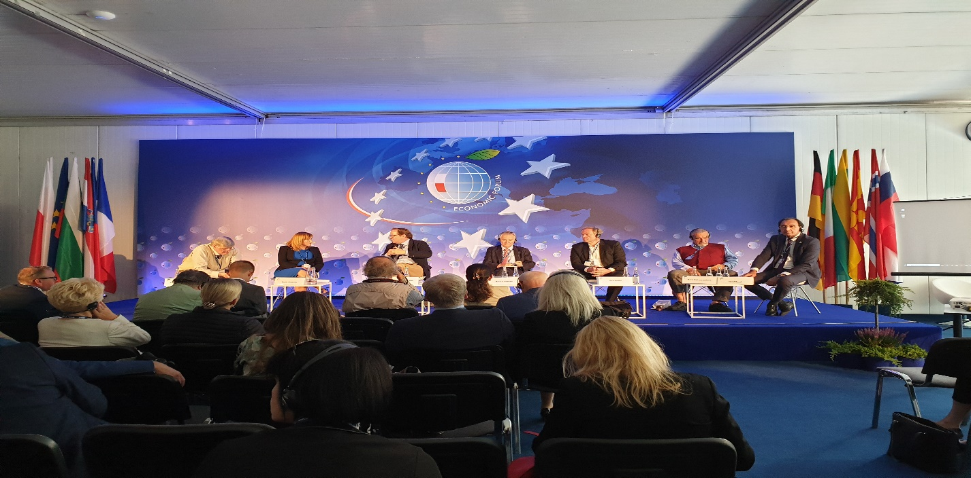

ECPR 13th General Conference, University of Wrocław, 4 – 7 September 2019
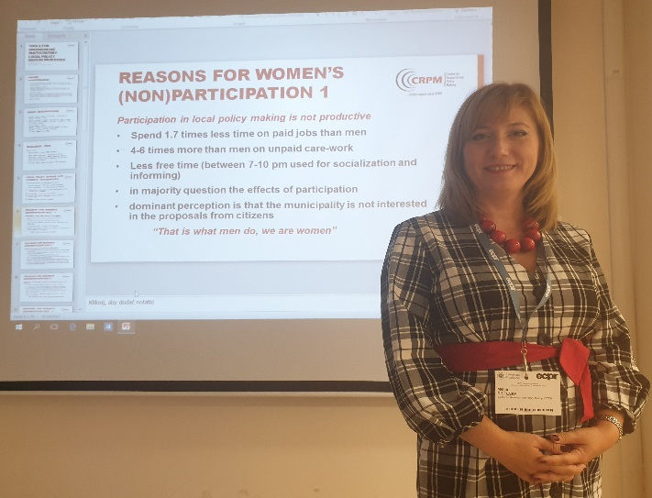
Dr. RISTESKA took part at the ECPR General Conference in Wroclow by presenting the paper Tools for Engendering Local Participatory Processes at the Panel: Multi-Actor Decision-Making in Local Affairs. The panel was chaired by PAWŁOWSKA, Agnieszka from the Institute of Political Science, University of Rzeszow and Co-Chaired by JÜPTNER, Petr from Charles University.

Economic forum on the 70 years of development and building of a community with a shared future for menkind – Shanghai 6-7th November, 2019
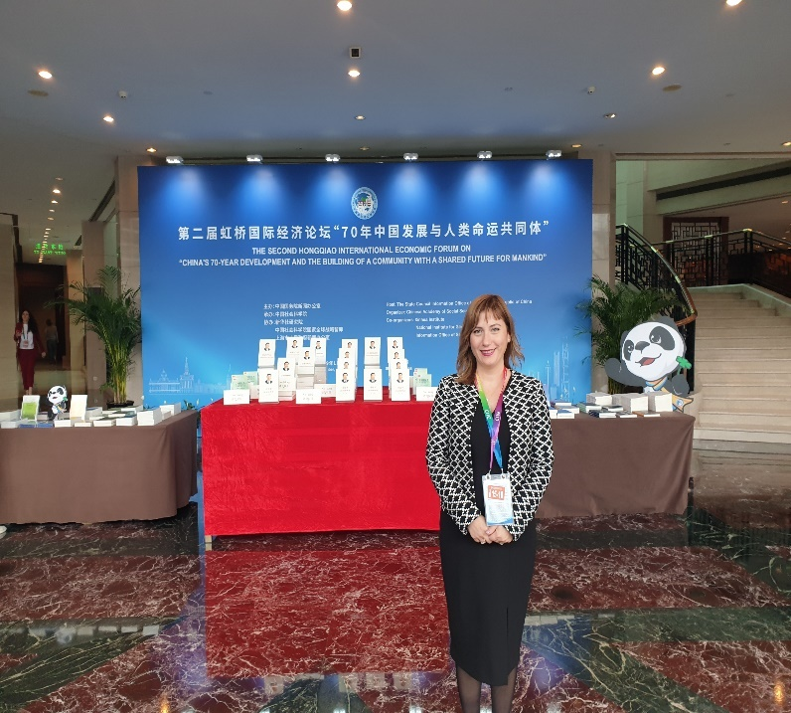
Dr. Risteska was representing the CRPM think tank among the 100 top think tanks in the world taking part in the discussions on the Economic Forum. Risteska presented the paper ‘Openness, Cooperation and Dialogue with China and the implications on EU accession bid of Macedonia’. This is an important scholarly contribution as in the public debate in the region and in Macedonia there is very little scholarly debate on the role and impact of relations with China. The little knowledge and interest is of course not the case with China only. Overall public debate is region, or Macedonia-centric, expending rarely to a wider outlook of the EU and trans-Atlantic security cooperation but again only limited to the region. Risteska concluded that the cooperation with China is normatively opposed to the orientations of Macedonia, that being following the European model of liberal democracy – this has especially come at a time when Macedonia’s government is primarily focusing on the number one foreign policy objective – and that is advancing its EU membership bid.

Western Balkans Summit in Poznań: strengthening links within the region and with the EU, 4-6 July, 2019
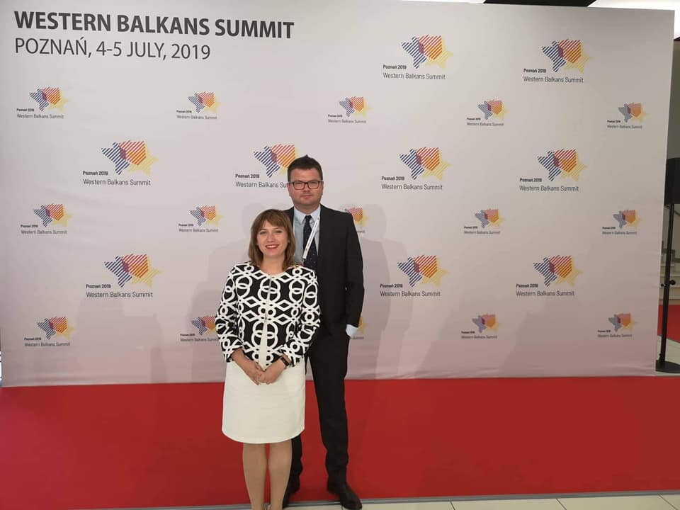
Heads of Government, Foreign Ministers, Ministers of Economy and Interior from the Western Balkans, together with their counterparts from several EU Member States and high-level EU representatives, met in Poznań to strengthen regional cooperation between the Western Balkans partners, as well as between the region and the EU, and to further advance the European integration process of the Western Balkans.
Dr. Risteska, CRPM Executive Director and Prof. Dr. Daskalovski Zhidas, CRPM School of Public Policy Mother Theresa Director participated at the Civil Society forum and contributed to discussions on development of democracy and good governance.

EU preventing and countering violent extremism training in WB, Sarajevo October 2019
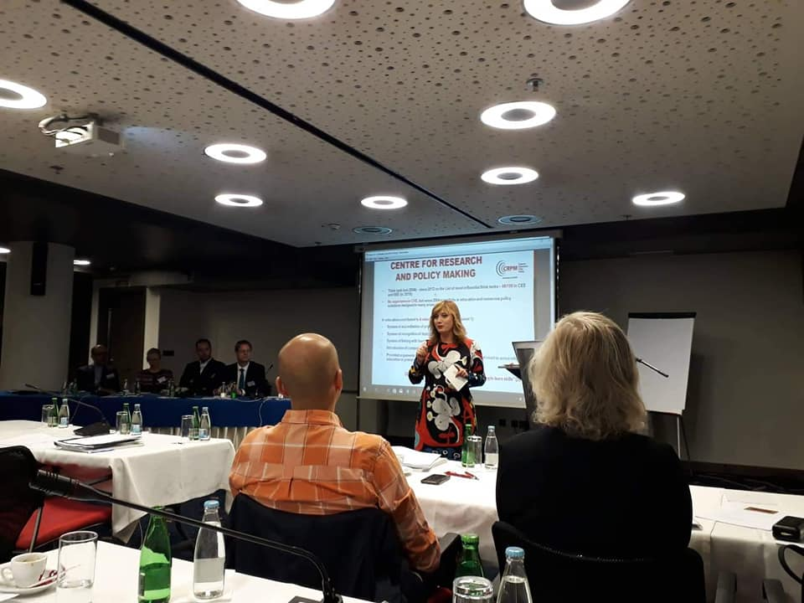
The EU together with the USI- Royal United Services Institute organized training in Sarajevo on preventing and countering violent extremism for CSOs, delegations of the EU in WB countries, and different stakeholder groups from academia and society. CRPM's Marija Risteska presented how through education will MK create passage for prevention from violent extremism. The results of the project on strengthening resiliance through use of education implemented with CED and Nexus were presented infront of representatives of EU delegations in Western Balkans with support of Hedayah Center for Excellence in countering and preventing from violent extremism.

Freja Forum 2019, Skopje 8-10 November
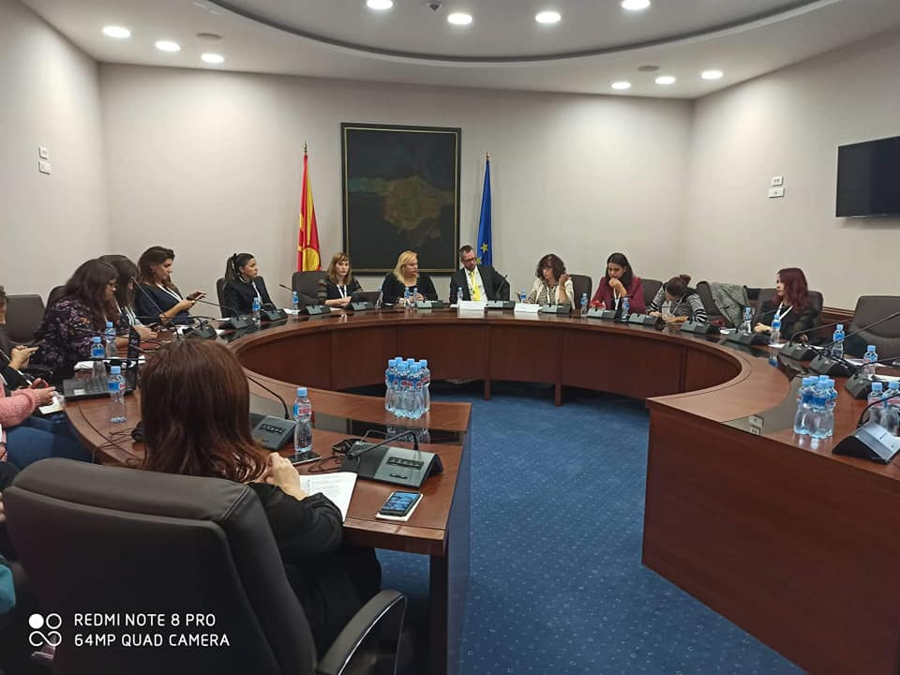
The 13th Freja Forum took place in Skopje. As a Forum Freja builds capacity to strengthen social structures, democracy and equal opportunities through the development of non-profit organizations in Western Balkan, Turkey, Sweden and other EU countries. The Forum discussed the current situation with the focus of a fair digitalization. Non-profit organizations and other actors must be better prepared and increase the knowledge of how a fair digital future can be created. Freja Forum has the aim of developing efficient processes in the non-profit sector to increase the competence and be strong and constructive players in the digital society.
Dr. Risteska presented the CRPM research on Girls in ICT The phenomenon is deeply rooted in the society and starts from an early age so that young girls are being raised as to seek security, find a job preferably in a “female” occupation (health, social work, education, or public administration) and not to “dream big”. The education system and society in general transfers from generation to generation the traditional divide of labour and care within the household, without any progress on this matter. This reflects not just on the horizontal market segregation based on gender but also vertical (within sectors) “whereby women are usually employed to execute the lower level jobs and the higher, better-paid and senior positions are almost exclusively filled by men. Jobs like sales assistants, technicians, professionals and clerks are mostly delegated to women” (Ibid).

1.2. Academic publishing
Book chapters in edited volumes
Daskalovski Z. “Serbia-Kosovo Relations and Its Implications on Security in Macedonia” in Bülent Sarper Ağir (Editor), Kosovo: Past, Present and Future, Nova Science Publishers 2019
Daskalovski Z. “EU Enlargement and Macedonia: Conditioning the Name” in Ingrid Shikova et all, (eds.) Papers from the Fifth International Scientific Conference of the European Studies “United we stand strong”, St. Kliment Ohridski University Press, Sofia 2019.
Risteska, M. (2019) “Through Redistribution, Recognition, Representation and Reconciliation in Education System Towards Building Resilience to Violent Extremism in the Republic of Macedonia” in Lessons From P/CVE Research Innovative Methods, Challenges, And Good Practices ed. Farangiz Atamuradova, Stuart Macdonald,Richard Burchill, Hedayah, 2019
Articles in refereed journals
Daskalovski Z. “Proportional Electoral Systems and Number of Parties in Parliament Evidence from Macedonia” in Politics in Central Europe, Vol. 15, No. 3, 2019
Daskalovski Z. “Republic of Macedonia or North Macedonia?” in Insight Turkey 21(2), January 2019.

2. CRPM policy research and analysis work
CRPM managed to maintain the reputation of being a leading Macedonian think tank offering original, excellent quality studies and briefs. The organization developed different products such as policy studies, policy briefs that are following the internationally accepted standards, but CRPM focused on the context and environment in Macedonia. The CRPM for the seventh time is ranked on the Global Go To Think Tank Index. The 2019 Report ranks CRPM 42nd on the List of Top 100 Think Tanks in Central and Eastern Europe. This is the policy work that was accounted in the ranking process:

2.1. Macedonian politics

School of Public Policy IMother TheresaI
In 2019 the School organized weekend seminars for the generation 2019/2020 (tenth overall) on the four subjects. The methodology of the seminars is based on lectures followed by discussions among participants, as well as a simulation games, quizzes and roleplays. Specific tasks and roles were to be given to the participants by the lecturers to equip them with skills that they can apply in the area of work and activism where they come from.
Liberal democracy, fake news, elections and media
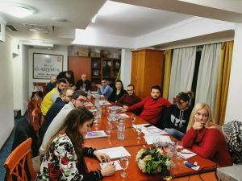
This session focused on fake news, internet portals and media developments in Macedonia. The underdeveloped policy framework for new media and the enabling environment for generation of fake news was debated as well as the digital and media literacy of the population, as well as the threats to liberal democracy digital media is causing.
NATO and New Threats to Liberal Democracy in the Balkans and Europe
This seminar was organized in cooperation with NATO. It focused on the Western responses to CVE threats in the Western Balkans. It explored in detail the security vs safety, dilemma in the context of the new threats and challenges for the Balkans NATO. Finally, one day was dedicated on discussing hybrid threats and hybrid security as new threats to democracy in the Balkans, with specific attention to cyber hybrid threats as a challenge to international law and threat to democratic values.
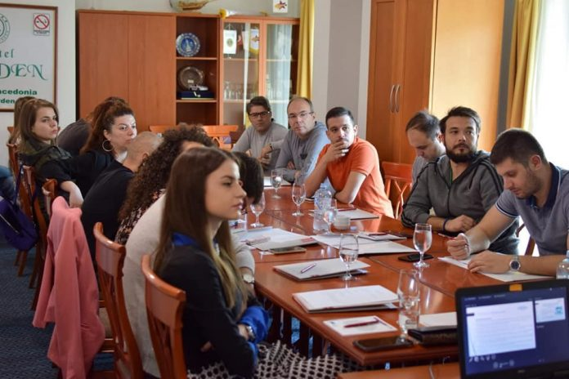
Preventing and countering violent extremism
The seminar was with an objective to pass on knowledge that will help the participants through active engagement to improve public policies and better tackle the threat of violent extremism. The School introduced the participants to the concept of violent extremism, the scope of the spread of the phenomenon in the country; research finding among youth and student in particular and finally models for prevention and disengagement, de radicalization.
Public Policy: from Theory to Practice
Traditionally the Schools delivers a session on public policy. It focuses on definitions, actors, processes of policy making. The stakeholders through workshops define policy problems, develop a stakeholder policy network, epistemic communities and how to design policy options and assess their impact.
In addition to weekend sessions the CRPM School organized weekly around 40 lectures and discussions.

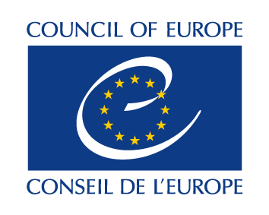
Funded by: Council of Europe, and NATO

EU POLICY BREAKFAST

Donor: Polish Embassy in Skopje
Budget : 4290 EUR

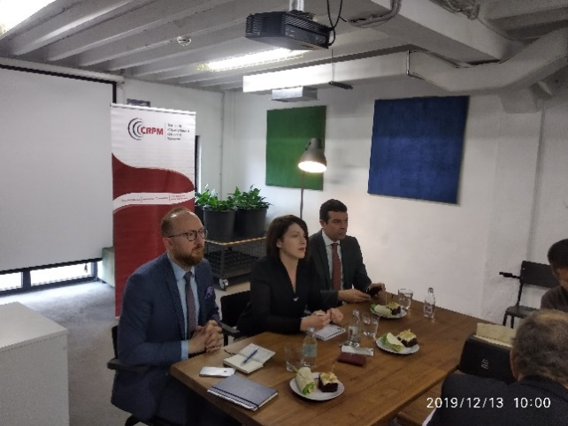
There is little informed debate and dialogue in the Macedonian society on important policy issues stemming from the EU agenda, especially in light of the forthcoming negotiation and accession process. We believe that dialogue is key to a peaceful and prosperous society that is mature enough to build consensus on the issues of paramount importance. So far, most debates have been either very high profile, under media pressure or with a hidden agenda, thus failing to yield substantial results. We propose a concept that will be free of such constraints and will deliver high quality input to policy makers by the civil society, academic and business community.

The objective of the action was to build consensus on a number of societal questions related to the EU accession process and promote a culture of dialogue and respect for other people’s opinions.

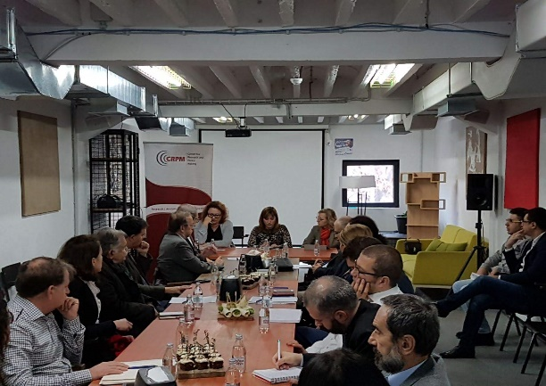
Therefore, we organized series of 3 debates on the following topics:

- Western Balkans – EU’s backyard or big powers’ testing ground?
- EU funds – means to support the reform process or wasted EU tax payers’ money?
- New model of enlargement policy – the way forward

The debate took place in Public Room in Skopje and was financially supported by the Polish Embassy in
Skopje.

The impact of Europeanization on the Balkan countries and their potential shift from the periphery toward the center
Donor: China CEE Institute
Budget : 11.988 EUR

The EU integration does not start or end with the accession, but goes on well beyond and expands by deepening the interconnectedness in different areas. It’s a process of profound transformation in terms of economy, politics and society. In that context, candidate and potential candidate countries undergo in-depth reforms. To that end, the study examines how the World-system theory applies to the 9 Balkan countries by analysing the impact that the EU integration process has had on the Balkan countries and on their respective shift from the “periphery” to the “center”. The analysis of a set of 25 pre-defined criteria collected for the period between 1990 and 2018 aims to verify or falsify if the EU integration process positively contributes to the shift of the accession countries from the periphery to the sеmiperiphery and core.
The comparative analysis of the economic indicators shows that EU integration has significant positive impact on economic development, trade and investments, especially through the Stabilization and Association Agreements. EU’s stringent rules have provided a solid framework for all the countries to stabilize their inflation and government debt levels. At the same time it concludes that while EU member states are more interdependent and more susceptible to shocks occurring inside the Union, as it was the case with the financial crises of 2008, the Balkans, although not fully integrated, are equally affected by EU’s internal turmoil.

2.2. Labor

The Adaptation of Industrial Relations towards New Forms of Work
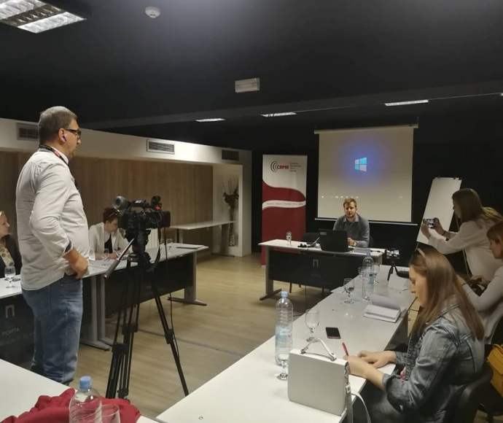
The Centre for Research and Policy Making in cooperation with five partner organizations from Bulgaria, Poland, Romania, Croatia and the Czech Republic implemented the project: ‘The Adaptation of Industrial Relations towards New Forms of Work’, supported by the European Union.

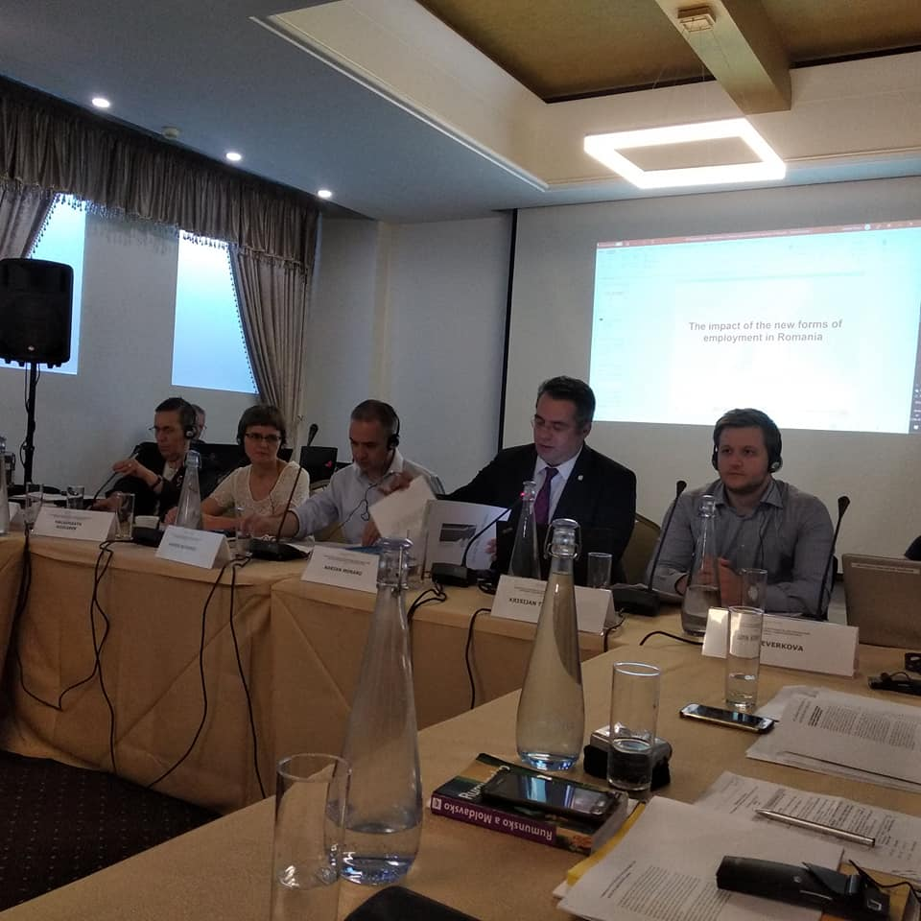
The Fourth Industrial Revolution, also known as the Digital Revolution is currently changing not only the human interactions, but also work-related interaction. In the context of technology’s evolution, labour market has considerably changed over the years, reshaping work relationships between employees, employers and their representatives, as well as working conditions, job skills requirements and overall job creation and job losses. New forms of employment pose serious challenges to the existing regulatory system of both labour taxation, but also social protection, balance of professional and private life etc. Within this project CRPM documented the scope and potential of development of new forms of employment and the digital economy in Macedonia, while putting the research in a context of the need for the traditional industrial relations main stakeholders (trade unions, employers organizations, state institutions) in order to adjust the national legislation and to identify the triggers for adaptation. We have noted that part of the new forms of employment can be applied with certain changes in the legal framework in order to increase the flexibility in the relation between workers and employers, as well they can contribute in reducing the undeclared work.
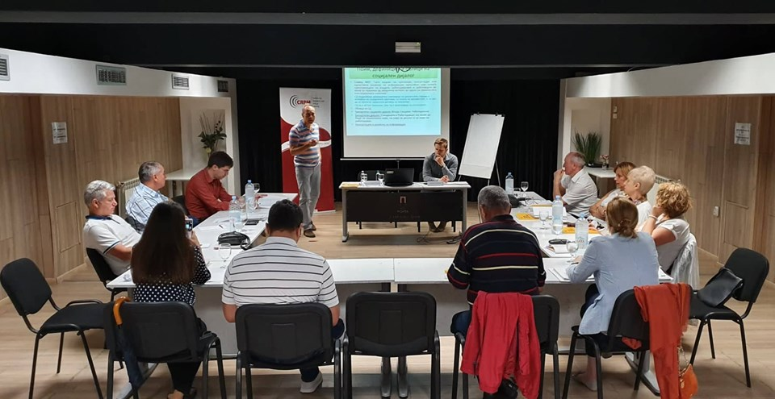
Budget: € 283.192,00
Funded by: European Union

Analysis of the legislation curbing informal economy
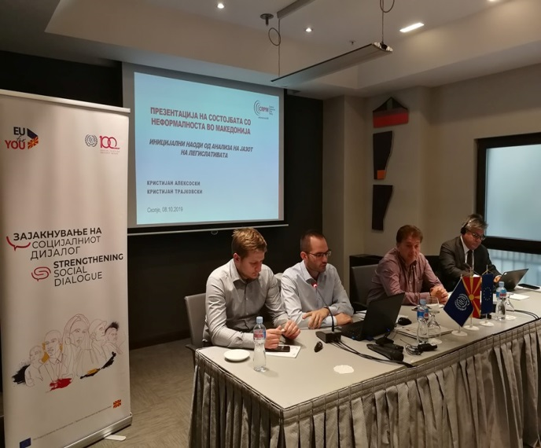
The Centre for Research and Policy Making (CRPM) in August 2019 was engaged by the International Labour Organization to prepare an analysis within the framework of the project "Strengthening Social Dialogue" which addresses the existing legal framework for the informal economy in the country and the condition associated with this phenomenon.
For that purpose, CRPM conducted a desk research covering nearly 20 legal acts (laws, by-laws), and additional information was gathered from the workshop attended by representatives of trade unions, employers' organizations, and representatives of the relevant ministries. CRPM research team also conducted interviews with prominent and experienced representatives from relevant institutions who have practical knowledge in this field.
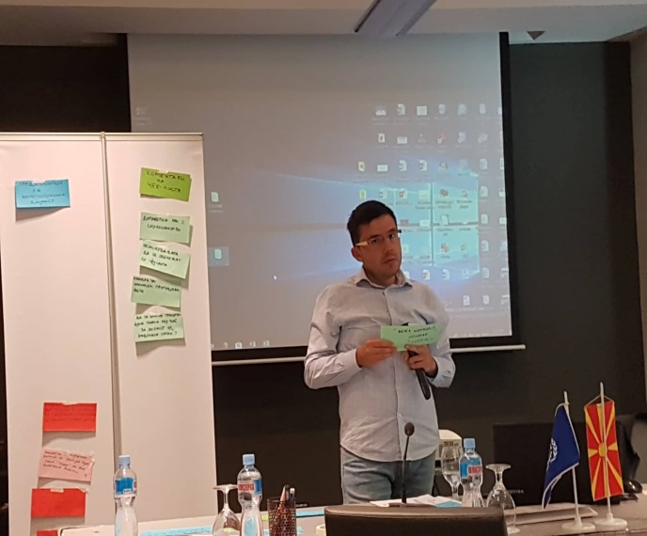
During the three-month work, CRPM research team focused on: (a) analysis of the relevant legal framework regarding the informal economy; (b) recommendations for harmonization of the reference law, i.e. the Law on Prohibition and Prevention of Unregistered Activity with the other material laws, in order to strengthen the legal framework for combating this practice; (c) creating a draft checklist that covers the provisions of the Law on Prohibition and Prevention of Unregistered Activity and will serve as a guide and sample for the further development for similar lists in accordance with the provisions of other laws, both for legal entities and the authorities in the inspection services.
The results were summarized in a document entitled “Gap Analysis of the Law on Prohibition and Prevention of Unregistered Activity”.

Budget: € 3.000
Funded by: ILO

Service contract for needs assessment for the Union of Independent and Autonomous Trade Unions of Macedonia
The Centre for Research and Policy Making (CRPM) in August 2019 was engaged by the International Labour Organization to prepare an assessment of the service needs of the Union of Independent and Autonomous Trade Unions of Macedonia. This activity was within the framework of the project "Strengthening Social Dialogue", funded by the European Union.
For that purpose, CRPM conducted a survey; face-to-face interviews with UNASM management, senior staff and board members; and focus group discussion with UNASM members. The assessment report contains a brief diagnostic review of the current situation in UNASM, SWOT analysis of the value of UNASM and where the organization is strong and where is weak, what opportunities exist for its agenda and what threats there are for it. Also CRPM research team developed several recommendations for creating relevant services for the current and potential members of the trade union. The recommendations include specific services and how UNASM can start providing new or enhance the existing services.
Budget: € 3.000
Funded by: European Union

Increasing employment opportunities for seasonal workers
The Centre for Research and Policy Making (CRPM) during the period September-October 2019 implemented several activities within the framework of the project “Increasing employment opportunities for seasonal workers”, implemented by NALED and supported by the German Development Cooperation (GIZ).
A CRPM expert worked on researching and collecting data for the project needs through a unified questionnaire. For the purpose of the research, a desk research was conducted (analyses of the legal framework), identification of stakeholders (relevant institutions, agencies, organizations etc.), estimating the size of the gray economy and informally employed seasonal workers. Also, during the research we assessed whether there is a possibility for applying the new model-system of hiring seasonal workers that started with implementation in Serbia since 1 January 2019. This model aims to facilitate the administrative procedure for hiring seasonal workers.
Representative of CRPM team presented the findings at a conference held in Belgrade, and contributed to the second conference where experiences were shared from the implementation of the new system for hiring seasonal workers.
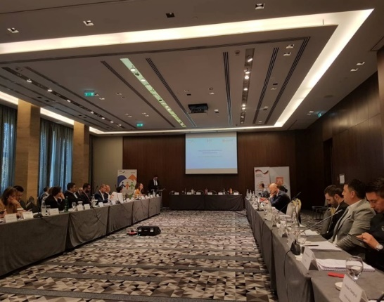
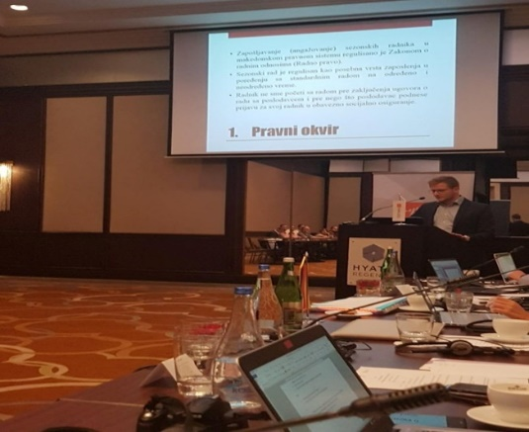
Budget: € 1.500
Funded by: German Development Cooperation (GIZ)

2.3. Education

Educate to Prevent - Strengthening Front-line School Workers and Parents to Build Youth Resilience to Violent Extremism

Donor: EU
Budget: 106.499 eur

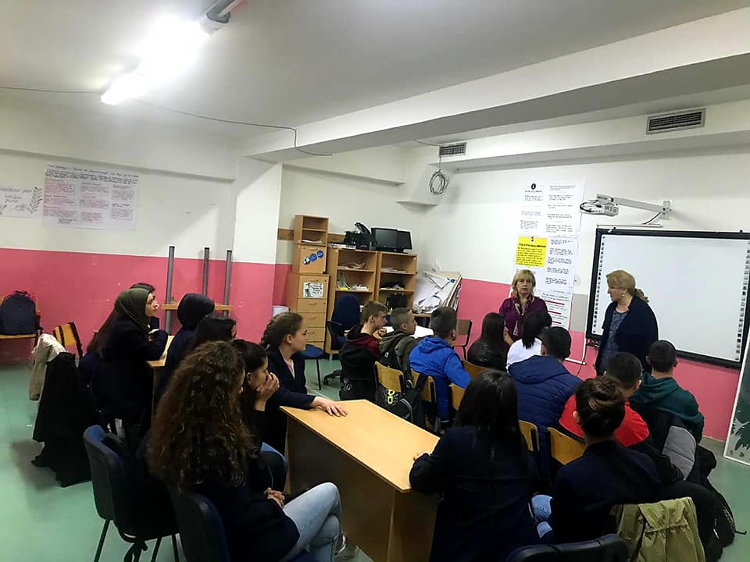
The project’s objective as described in the application form is to develop community resilience to Radicalization and Violent Extremism was attained through the completing the specific objective set out in the document. During the project cycle the project partnerships were built with numerous stakeholders such as the National Committee for Countering Violent Extremism and Countering Terrorism (NCCVECT), the ministries of education and internal affairs, as well as with the eight municipalities within the three regions where the activities are implemented. Lastly, synergies were built with the OSCE Mission to Skopje (OSCE MtS) and the International Organization for Migration (IOM). This trend of nurturing the partnerships and expanding the circle of partnership with new CSOs that work in the same field has continued in the period cover by this report.
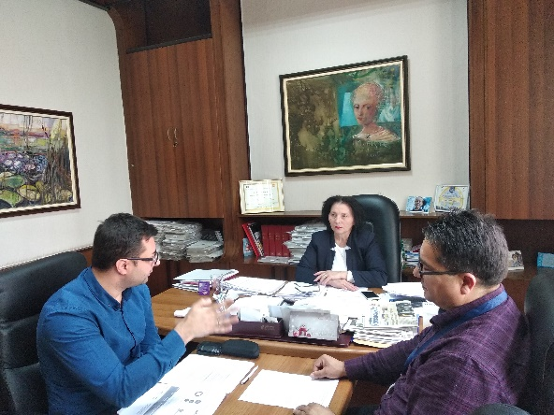
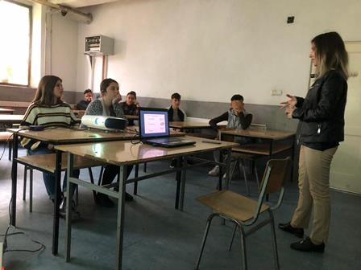
The action has managed to build capacities of frontline school workers through developed training program which was conducted successfully with the school workers in 4 municipalities (Tetovo, Gostivar, Kumanovo, Skopje). As a follow up to this activity, mentorship activities were carried out consisted of 84 visits to schools encompassed with the capacity building activities by the selected mentors to guide them through the process at their workplace in using the checklist and protocols for dealing with radicalization and countering violent extremism. Furthermore, the referral mechanism at a local level was developed as part of the working package 2. The referral mechanism was presented on workshops in 4 target municipalities with relevant stakeholders, bearing in mind the holistic approach the action is based on.

“Development of a municipal preventive system / referral mechanism for VERLT (activity 5) and “Strengthening Social Cohesion in the Country (Activity 21 and 22)

Donor: OSCE mission in Skopje
Budget: 2.100 eur

The policy expert Dr. Marija Risteska was engaged to develop a model of preventive system based on analysis of relevant researches and documents in the field.
The preventive system took the form of a referral mechanism where local stakeholders (psychologists, pedagogists, school workers, representatives of the local government, religious leaders and other) will work closely, following a protocol that defines their roles and procedure in case radicalization is noticed in the community.
The referral mechanism was presented to the local stakeholders in the targeted municipalities. The workshops have taken place in Gostivar, Tetovo, Kumanovo and Skopje (Gazi Baba, Saraj, Aracinovo, Aerodrom). The feedback of participants was taken into consideration and it was integrated in the final version of the document.
Developed Guidebook for preventive system: This activity is completed. The expert was selected (Ivan Stefanovski) to develop the Guidebook based on the referral mechanism. The idea is, this Guidebook for preventive system to help local stakeholders in implementation of the referral system for prevention of radicalization, explaining the procedures and roles of each agent.

Safe Internet – Resilient Youth
Donor: City of Skopje
Budget: 2.500 eur

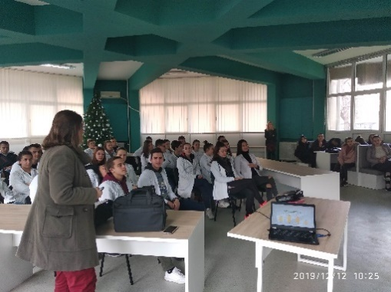
The project "Safe Internet – Resilient Youth" was implemented in the period from 15.04.2019 - 15.12.2019, and was financially supported by the City of Skopje.
The aim of the project is to raise the awareness of high school students about the risks on the internet in order to strengthen students' resilience to radicalization and violent extremism by enhancing collaboration between students, parents and teachers.
The main activities within the project included the development of the following products:
1. The Guide for @ Safe Schools
The guide covers the most important aspects of cyber security without going too far into expert terminology that we believe will burden the text, making it more difficult for students, parents and teachers to understand. So, we tried to make the language as comprehensible as possible, and at the same time provide useful information on the topic we are covering.
2. Days for @ Safe Schools
The guide covers the most important aspects of cyber security without going too deep into expert terminology. So, we tried to make the language as comprehensible as possible, and at the same time provide useful information on the topic we are covering
3. "Take home" contracts
Take - home arrangements were presented to students, teachers and parents to encourage discussion among these stakeholders about internet safety and the safety of their children.

2.4. Gender

Advocacy and expert level dialogue with Government and Parliament to amend existing legislation in the field of gender-based violence and gender-based discrimination, in line with international standards, human rights mechanisms recommendations (UPR, CEDAW, CAT, CERD, CCPR, CESCR), EU Directives and Istanbul Convention

Donor: UN Women and EU
Budget: 34.300 EURO

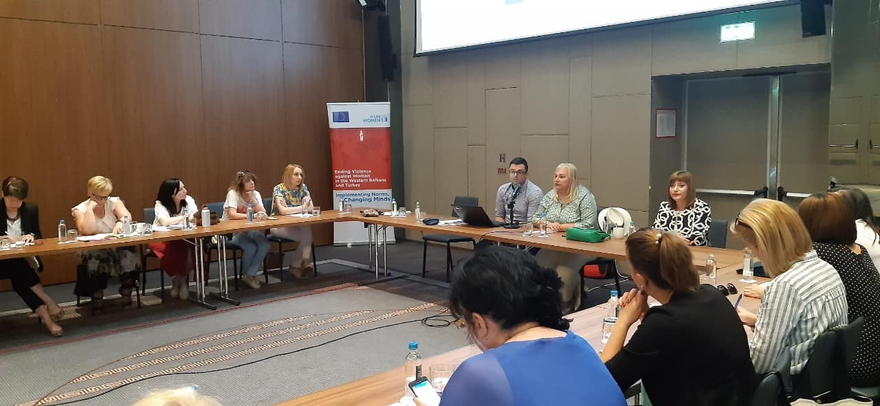
In partnership with the Macedonian Women’s Lobby, CRPM has been implementing the project funded by the UN Women, which objective is to provide support of the process of implementation of the Istanbul Convention in Macedonia. The project activities encompass two types of activities: research and advocacy. Within the first type of the activities, main product is the gap analysis which proved a clearer picture on what should the process focus on, based on the gaps between the requirements of the Istanbul Convention and the actual state of affairs in the Macedonia related to the protection victims from the gender based violence. The Analysis was presented at the final event held in Hotel Marriot in Skopje were representatives of relevant stakeholders were present.
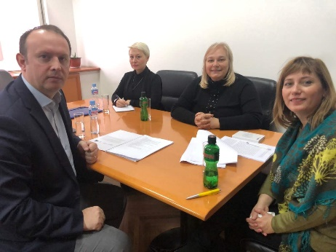
In the second phase of the project, the project management team held advocacy meetings with members of the parliament, president of commission for equal opportunities, and other women lobbies groups, In addition to this, 3 expert level dialogues were held in which different aspect were discussed related to amendments of the Criminal Code for complying with the provisions in the Istanbul Convention.

Gender Budget Watchdog Network
The policy making and budgeting processes in SEE and R. Moldova are closed, non-transparent and result with policies that do not respond equally to the needs of women and men. Moreover, public resources are not distributed in just and equal way between men and women. CSOs have limited capacities to contribute to gender assessment of the budget as a policy document and have seldom focused on the collection of revenue and distribution of expenditures by assessing them from the perspective of equity, fairness, and efficiency.
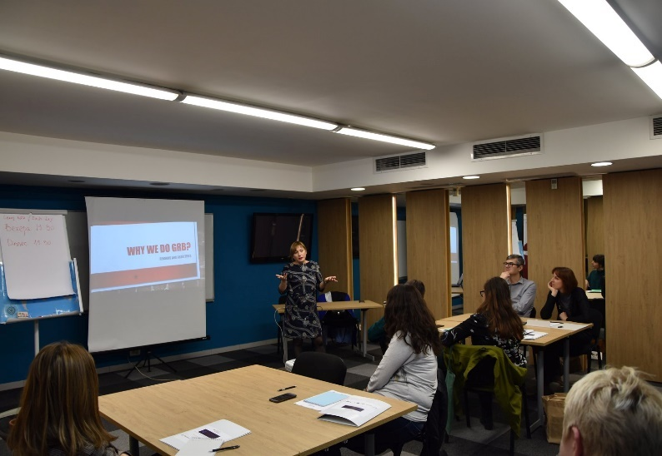
Overall objective of the Gender Budget Watchdog Network is to improve CSO participation in policy and budgeting processes in South East Europe and R.of Moldova by using gender budget watchdog reporting and networking. Project purpose: (i) to strengthen the capacity of CSOs to use GRB tools to evaluate the correspondence of policies and budgets with the needs of men and women; (ii) to develop a network for effective policy advocacy, knowledge and information sharing and strengthened government accountability; (iii) to engage citizens and contribute to policy change leading to gendered reform of public finances.
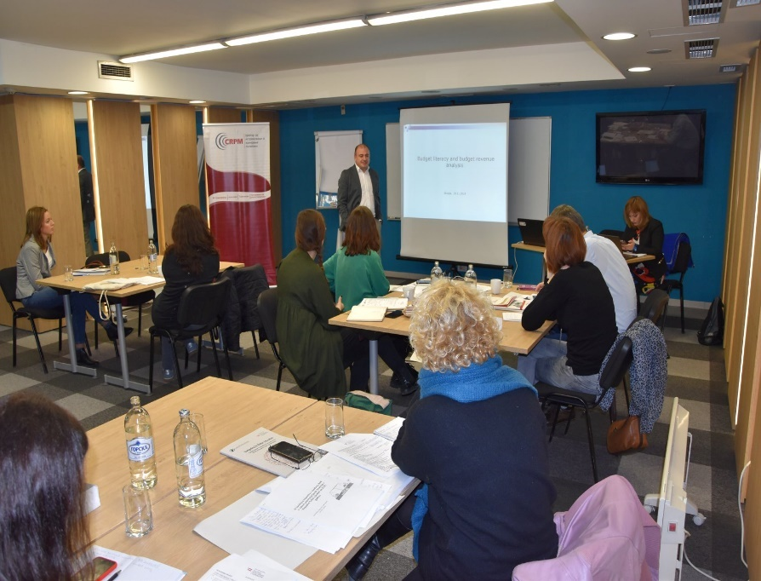
In 2019 the project commenced and implemented the following activities from the first component of the project: Call for applications for CSOs was published, CSOs selected, Training needs assessment conducted and based on it a Training program was developed. The project partners internalized knowledge and methods/ approaches to application of GRB tools by civil society during the ToT training delivery. From the second project component, as per the project plan none of the planned activities happened, but several preparatory activities were implemented. In example the project partners had several online meetings with Women budget group to prepare first study tour agenda, schedule meetings for study-tour and organize events. Also, each of the project partners undertook logistical organization of their visit to UK (visa, lodging, travel, insurance and etc.) In the third component no activities were implemented neither preparation commenced in the reporting period.
In 2019 the project resulted with selection of 88 CSOs to be included in the GBWN, assessment of their GRB capacity, and development of training program for acquiring skills to appraise gender responsive policies and to hold governments accountable for the gender impact of proposed policies and budgets on the national and subnational level. In this respect in the reporting period the activities implemented contributed to partial realization to the first expected project result. Considering that the project partners also went through a Train the Trainers Training a first step towards the achievement of the second result has been made – the Civil Society Organizations that are part of the GBWN act as a hub for knowledge on GRB.

Implementing Norms, Changing Minds – Pre and Post Survey
Donor: UN Women and EU
Budget: 19.100 €

A survey was conducted in December 2019 as a final activity within the project "Implementing Norms, Changing Minds" . Its results are still processing and upon completion, they will serve as a reference point to compare to the results of the pre survey that was conducted in 2018. This survey covered exactly 600 respondents in 27 municipalities in the country, and the data and answers were operationalized with the SPSS tool. As in the initial survey, the questions were divided into four categories:
a) a general perception of gender and related issues;
b) views on gender-based violence;
c) attitudes towards acceptable behavior of men and women; and
d) attitudes to change / improve gender equality, violence against women and girls and domestic violence;

Based on the preliminary work, we can say that Macedonian citizens have open minds and attitudes when it comes to the professional development of women, however still some traditional believes are preserved related to the expectations of the women to perform “her daily domestic routines in terms of maintaining the household and providing continuous care for the children”.

3.6 Sustainable development
Smart Start
Donor: EU
Budget: 158.276 €

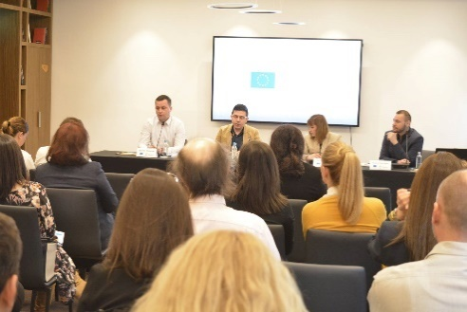
In 2019, we successful concluded this project. The final event was organized in March at which showed up more than 70 guests. The event was attended by Maria Risteska, Executive Director of CRPM, Irena Ivanova, EU Delegation to the Republic of North Macedonia, Damir Zekovic, Smart Start Program Manager from Bosnia and Herzegovina, Dusan Tomsic, Ministry of Labor and Social Policy, Kiljan-J . Andres Eskoyola, Home Hub Africa and Ceylan Osunel of the JADA Foundation Wakfi. At the closing event, through the presentations of their previous work, some of the organizations that were transformed into social enterprises took part and presented their achievements. A special exhibition space was created in the lobby where all sub grantees exposed their products / services. Additionally, at the event a discussion was opened on the current state of affairs regarding the social entrepreneurship enabling environment in the country and the potential strategies that can be applied to boost this type of economic activity. The 10 sub grantees continued with their implementation of the business plans and successfully finished them by providing tenable results, both in financial and pogrom terms. An advocacy campaign was implemented and completed in this year too. In this time slot, a portal banner was designed in order to promote the project and the achieved results. A video for the achieved results in a HD format was also produced in order to boost the general awareness but also to promote the project. The video can be found at: https://www.youtube.com/watch?v=KJ8lGz6mI4 I .A continuation of the interviews with the sub grantees was also done, promoting their business plans as well as the overall project idea and the benefits of their SEs.

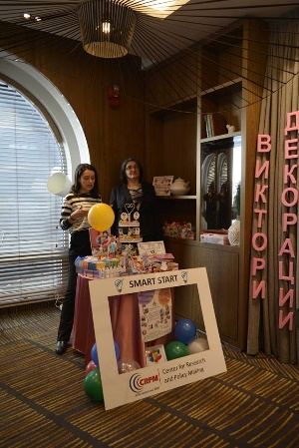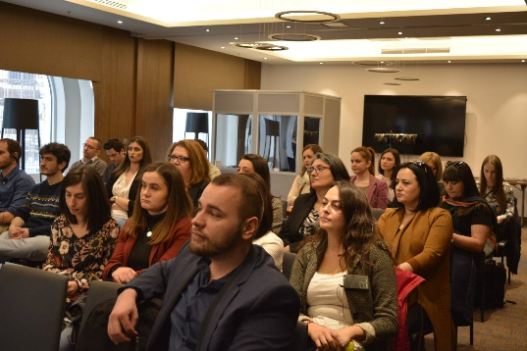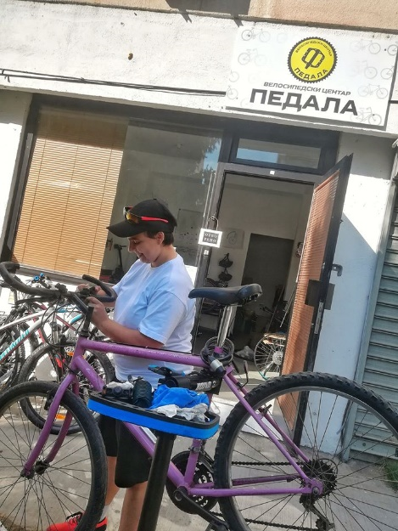

Regional cooperation and competence development of parliamentarians of South –East Europe on energy efficiency, climate topics and sustainable urban mobility
Donor: GIZ
Budget: 29.389 €

On 13/03/2019, a parliamentary hearing (coordinative meeting) was held in the premises of the Macedonian Parliament to discuss the challenges and tasks that stand before the Republic of Northern Macedonia in the light of the negotiations for full membership in the EU in relation to chapters 15 ( Energy) and 27 (Environment). The previous research on this topic was organized in a White paper. The meeting was attended by MPs Secretariat for European Affairs working on these chapters, as well as representatives from the Ministry of Economy and the Ministry of Environment, At the hearing, representatives of the NGO sector, represented by "Eko svest" and the Macedonian Ecological Society, took an active participation. At the meeting, the greatest attention was paid to the need to strengthen the administrative capacity of the relevant institutions with quality staff to effectively lead the negotiations, but also to implement the directives and regulations imposed by the common European law. Additionally, MPs were emphasized that there are cases when adopting a certain new law unconsciously a collision is made with other already existing ones, especially in the area of laws related to the environment and mineral resources. At the meeting it was emphasized that the new Law on Energy Efficiency is almost before to adoption by the Government, and is expected after the end of the presidential elections to be send to the parliament. The Center for Research and Policy Making in cooperation with Prishtina Institute for Political Studies, with the support of GIZ Open Regional Fund for South-East Europe - Energy Efficiency held the joint informative session on sustainable urban mobility planning with representatives from the Assembly of the Republic of North Macedonia and Kosovo in Pristina from 24-25th April, 2019.The event was focused on the main sustainable urban mobility concepts and the role of the National Assembly in optimal planning of urban spaces. Mr. Aljaz Plevnik was appointed as a trainer, whereas the event was used for additional cooperation among the MKD and KOS MPs in the topics related to the project which presented added value o the overall project. Finally, we presented another White paper, but this time it addressed the urban mobility channelings in Skopje and Bitola. The White Paper should serve the purpose of defining the vision and direction that will take the country and
the municipalities in terms of sustainable urban mobility and serve as a guide for all other stakeholders. The presentation was performed during the session of the Commission of transport, communications and ecology and it was chaired by its president MP Liljana Zaturoska on 20/09/2019 as an activity of the Urban mobility week in our capital.
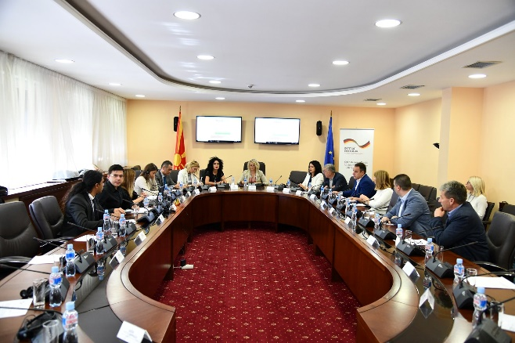
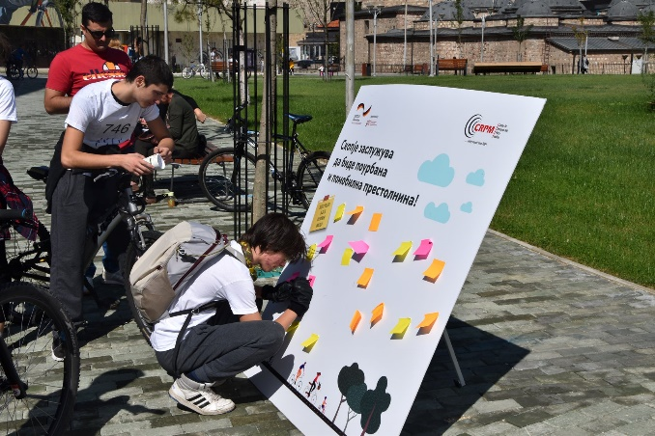

Enhancing Livelihoods and Income Generating Opportunities for Returnees: Establishment of a Textile Manufacturing Cooperative in Shuto Orizari
The overall objective of this activity was to establish a local social entrepreneurship structure and in coloration with local Roma CSO - Ambrela. CRPM and Ambrela reached out to asylum-seeking returnee women from the EU and helped improve their opportunities for obtaining gainful employment, develop their professional skills and competences and create self-employment opportunities for them. Special attention was paid to Roma women exposed to multiple discrimination risks.
The following results were achieved in Shuto Orizari:
• Developed business plan for social enterprise;
• Equipped working space with 9 professional sewing machines and additional accessories;
• Trained 20 Roma women to produce traditional wedding dresses called “dimija” or “shalwars”, which are in high demand in the community of Shuto Orizari;
• Five Roma women employed;

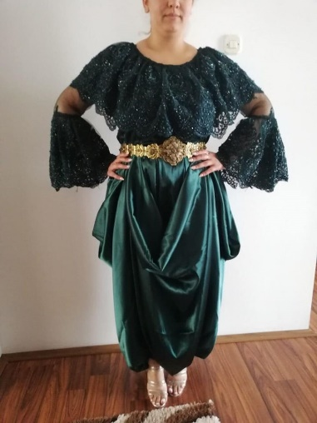

4. CRPM events

World Forum of Democracy
The CRPM School of Public Policy Mother Theresa contributed to the organization of the 2019 World Forum of Democracy on the topic: Is democracy in danger in the information age? Information is changing. The volume, the content, the platforms: each of these has evolved beyond recognition in a short period of time. This evolution continues. The questions we must address in 2019 are to what extent the information is reliable, whether this helps or hinders citizens in taking part in democratic processes, and what lessons we should learn for ensuring the free flow of information in the future.
The forum was held in Strasbourg, in the period 6-8 November 2019 and the generation 2018/9 of CRPM School of Public Policy Mother Theresa participated at the World Forum for Democracy. Look at the video the generation produced for the experience in the School and WFD. https://www.youtube.com/watch?v=LyELYNhwO58&feature=youtu.be
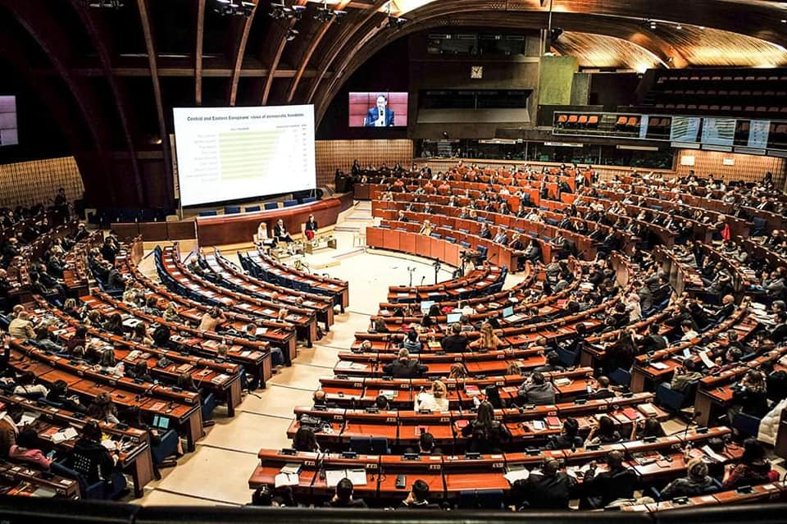

NATO SPS
Educate to prevent: CVE educational and Municipal Practitioners Community of Practice and Exchange Workshop

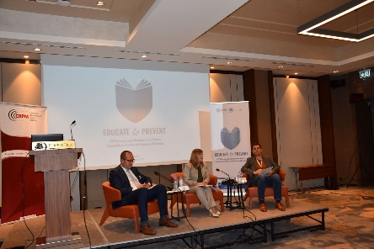
The Center for Research and Policy Making – Skopje (CRPM), in cooperation with the Institute for Democracy and Mediation from Albania (IDM) hosted an event – advanced training course on Countering Violent Extremism Community of Practice and Exchange Workshop. The workshop was organized in the framework of the NATO’s Science for Peace and Security Program and was held at Hotel Double Tree by Hilton in Skopje on 05-09th June 2019. The event was co-financed by NATO, and the EU (through the Strive Program on CVE, implemented by Hedayah). The program was developed and delivered in partnership with OSCE and in coordination with the IOM regional program on CVE, the Regional cooperation council as well as the National coordination office for countering violent extremism and terrorism of the Republic of North Macedonia.
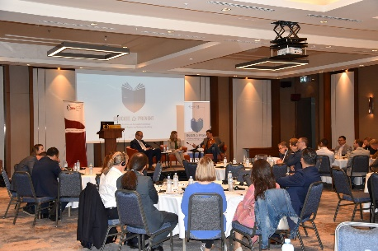
There were several panel discussions over the five-day workshop course on various topics regarding the prevention of violent extremism and building resistant community of practitioners. Each day of the event was devoted to a specific topic. The goal of the workshop was to enable exchange of experiences between the education and municipal practitioners whilst presenting the best European and world-level practices through the interventions of renowned experts. RCC’s role in regional cooperation for Prevention and Countering of Violent Extremism, Ensuring an impactful and effective role of civil society in PVE: practitioner perspectives of working with youth, women and community leaders, Introduction into key concepts to referral mechanisms: analysis of strengths and risks were some of the topics that were discussed.

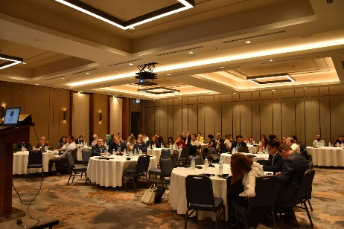
Vulnerability to hybrid threats in the Western Balkans
The Center for Research and Policy Making and the Romanian Embassy in Macedonia, in the framework of the Romanian presidency of the Council of the European Union, organized a discussion on the topic "Vulnerabilities of propaganda in Western Balkans". Speakers at the event were Rufin Zamfir, Director of Asymmetric Threats Programme at GlobalFocus Center and Oana Popescu, Director of GlobalFocus Center. The event focused on presenting the contextual findings of the qualitative and quantitative analysis of the permeabilities / vulnerabilities to propaganda in the Western Balkans.
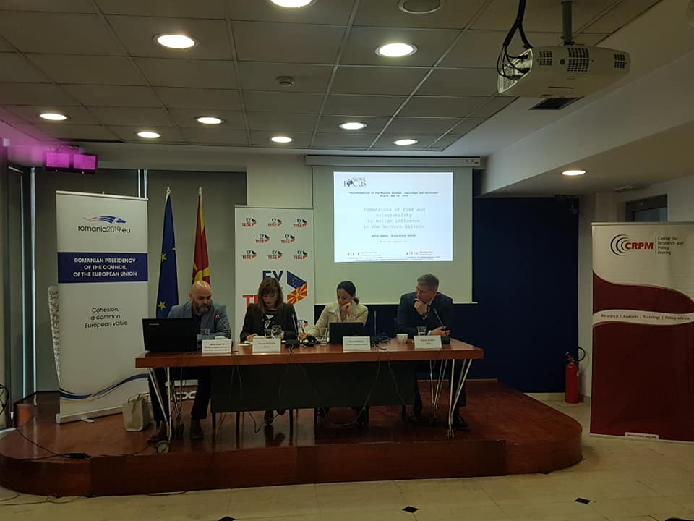

5. Outputs/ Results:

5.1. Books
The adaptation of industrial relations towards new forms of work

5.2. Policy briefs
White paper on the development and planning of sustainable urban mobility in Republic of North Macedonia
Comparative report on changes from baseline to end line period: Republic of North Macedonia

5.3. Policy Studies
Perceptions of front-line school workers and community officials from Skopje, Kumanovo, Tetovo and Gostivar on radicalization leading to violent extremism: Baseline study
The New Forms of Work: a Comparative report

Needs analysis on criminal code compliance with the Istanbul Convention in the Republic of North Macedonia

5.4 Policy initiatives
Referral mechanism for prevent from radicalization

5.5. Guides
Handbook for teachers in secondary schools and tools for early detection and action
Guidebook for the Operationalization of the Passege4Prevent Referral Mechanism in North Macedonia: From Structure to Agency
Manual on cyber safety for children at home and school
Manual for employees: guidebook on workers ‘rights

II. Financial report 2019

Center for Research and Policy Making – CRPM Skopje

Financial report
01.01.2019-31.12.2019

INCOME
- Income from memberships 247.000mkd.
- Income from interest rates and exchange rates 57.820 mkd.
- Income from projects 27.384.552 mkd.
- Income from donations 61.500 mkd.
- Income from SPP Mother Theresa 61.500 mkd.
- Income from consultancy and other services 455.464 mkd.
- Transferred surplus from last year 6.531.347mkd.
- Special incomes (interest rates and previous incomes) 300.819mkd.

Total income 35.100.002 mkd.

COSTS
- Costs for office supplies 134.132mkd.
- Costs for energy supply 93.223mkd.
- Costs for publications and printing 555.091mkd.
- Costs for rent of venues and equipment 907.414mkd.
- Costs of hotel and catering services 3.150.881mkd.
- Transport and transport related costs 85.546mkd.
- Contracts for services 3.685.247mkd.
- Commercials and presentations 45.632mkd.
- Travel costs and per diems 733.278mkd.
- Transfers to partner organizations 9.148.063mkd.
- Negative exchange rates 30.579mkd.
- Bank fees 84.072mkd.
- Other costs 6.151mkd.
- Gross salaries 3.987.807mkd.
Membership costs 3.200mkd.
- Costs for research, organizing seminars, design and related 887.003 mkd.
- Purchase of basic means and small inventory 123.167 mkd.
- Other costs 17.242mkd.
Total costs 23.677.728 mkd

BALANCE SHEET

31.12.2019

Assets

- Non-current assets
  - Basic assets 199.218mkd
- Cash
  - Denar account 6.257.866mkd
  - Foregin currency account 4.962.540mkd
- Cash equivalents 149.679mkd
- Prepaid expenses
  - Other prepaid expenses 31.737mkd
- Receivables from domestic and foreign legal entities 24.600mkd

Total assets 11.625.640 mkd

Liabilities

- Sources of funds
  - Business fund 199.218mkd
- Short-term liabilities
  - Short-term financial liabilities 4.148mkd
  - Tax liabilities 0cmkd
- Accrued liabilities
  - - Assigned funds for 2020 11.422.274mkd

Total liabilities 11.625.640 mkd

