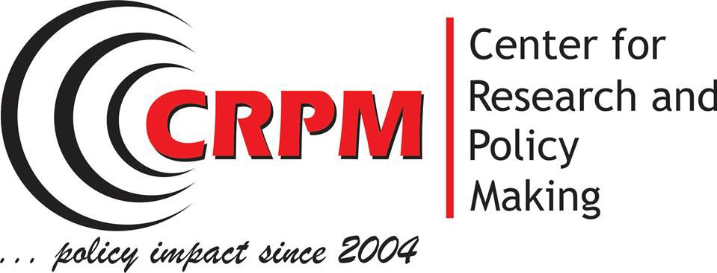

Annual Report, 2018

This document summarizes the activities undertaken by the Centre for Research and Policy Making in the course of implementation of its 2018 work program. It reports on outputs and impact the CRPM work has on policymaking in Macedonia and South East Europe.

Table of Contents
I. GeneralReport 3
1. Academic activity of CRPM members 4
1.1. Conference participation 4
1.2. Academic publishing 5
2. CRPM policy research and analysis work 6
2.1.Macedonianpolitics 6
2.1.1. School of Public Policy “Mother Theresa” 6
2.1.2. Youth mobility 7
2.2. Good governance 8
2.2.1. Rule of law 8
2.2.2. Index for Youth Development in Macedonia 8
2.3. Labor 8
Industrial Relations in Central and Eastern Europe: Challenges Ahead of Economic Recovery Error! Bookmark not defined.
2.4. Education 10
2.4.1. E2P 10
2.4.2. Learning to learn skills 10
2.5. Gender 10
GRB watchdog reports 11
3.6 Sustainable development 13
4. CRPM events 15
World Forum of Democracy 15
RIRA forum 16
5.Outputs/ Results: 17
5.1.Books 17
5.2.Media 18
5.3.Policy briefs 18
5.4. Policy Studies 18
http://www.crpm.org.mk/wp-content/uploads/2018/12/The-Rule-of-Law-in-Macedonia.pdf 19
5.5. Policy initiatives 19
II. Financial report 2018 20

I. GeneralReport

The 2018 was a year full of new challenges. The Centre for Research and Policy Making – CRPM embraced these challenges with open arms. Our team has embarked bravely in four new policy areas: countering violent extremism, new forms of work, gender-based violence and investment policy. To this end we have produced the first assessment of perceptions on radicalization in high schools located in 8 municipalities in the country; developed comprehensive research on the challenges workers face with the fourth industrial revolution that brought us the gig-economy and digitalization of work; conducted a field survey of perceptions on advocacy for gender based violence in the country and finally built capacity and invigorated policy debate between businesses, the state authorities and CSOs on what the regional agenda for investment should incorporate.
Dr. Marija Risteska, Executive Director
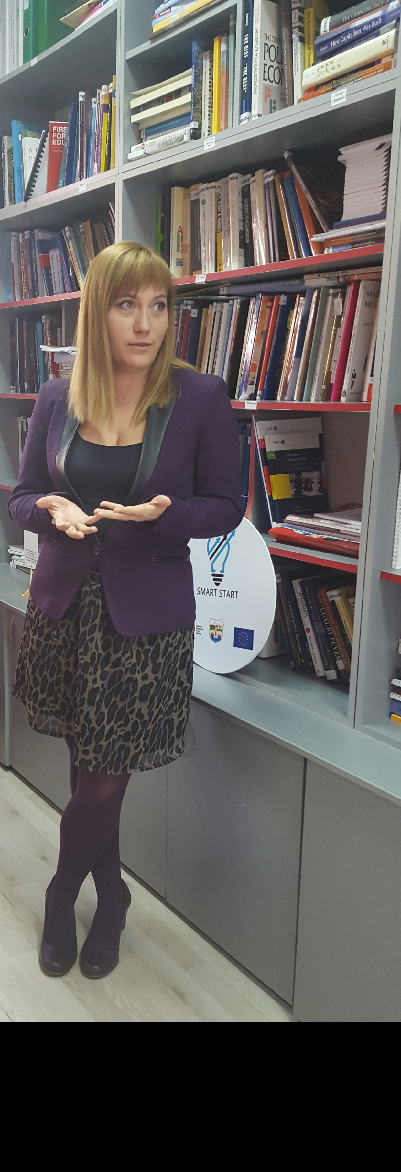

risteska@crpm.org.mk
@risteskamarija

CRPM, in the course of the 2018, has revisited its interest in youth by creating the Index for youth development, and the study on youth mobility. Continued working on education, energy efficiency, social entrepreneurship and climate change. We also welcomed a new generation of students in the CRPM School of Public Policy Mother Theresa and has celebrated the graduation of the 2017-2018 generation of students at the World Forum for Democracy in November 2018.

The team is also proud to have pioneered research work in the region on the regional investment agenda; creating an Index for Rule of law in Kosovo and Macedonia and promoting the Hidden economy index for Macedonia, Kosovo and Albania. In addition, our methodology for gender budget watchdog reporting has been exported to Moldova and Albania. With these achievements the Centre for research and policy making is fulfilling its long-term objective to become one of the most prominent think-tank in South East Europe. Its position to be the leading think tank in Macedonia has been again evidenced with the McGann Think Tank Index of University of Pennsylvania which in 2018 ranks CRPM 48th on a list of 100 think tanks from CEE and SEE and the Think Tank transparency index which gave 5 stars for transparency to CRPM.

Our funding remained diversified which ensured stability, sustainability and independence of the rigorous analysis and policy advocacy of the CRPM team.

1. Academic activity of CRPM members

Conference participation

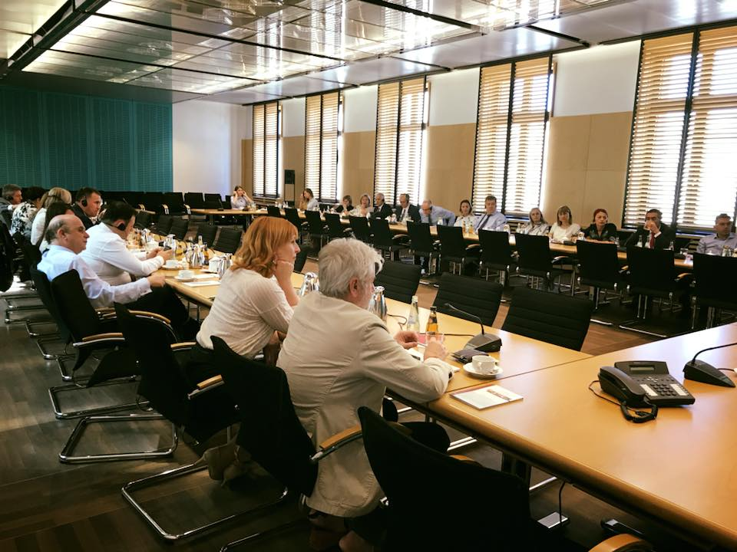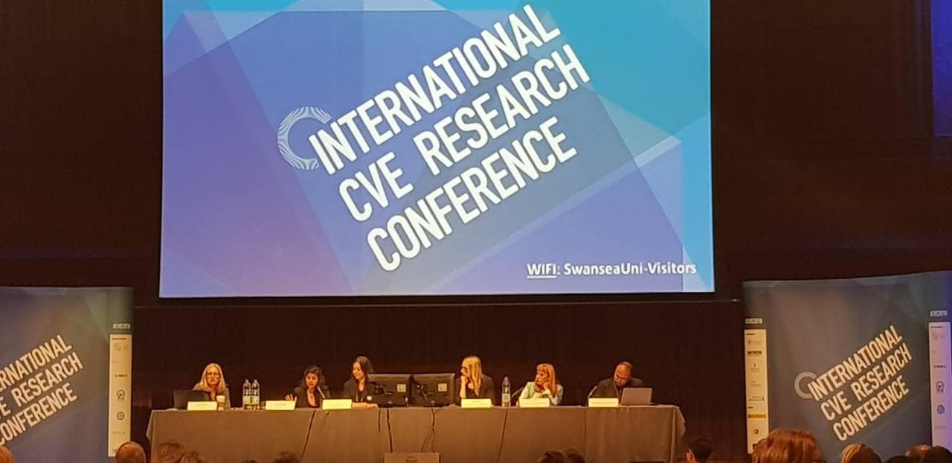
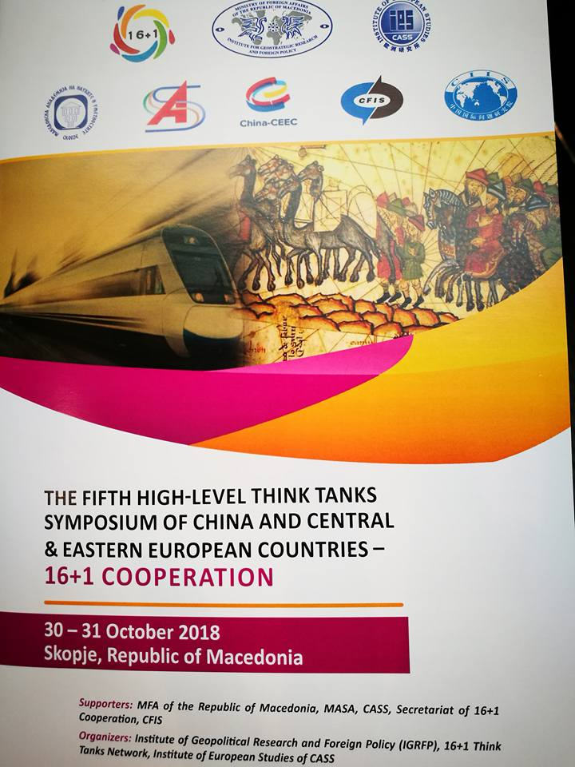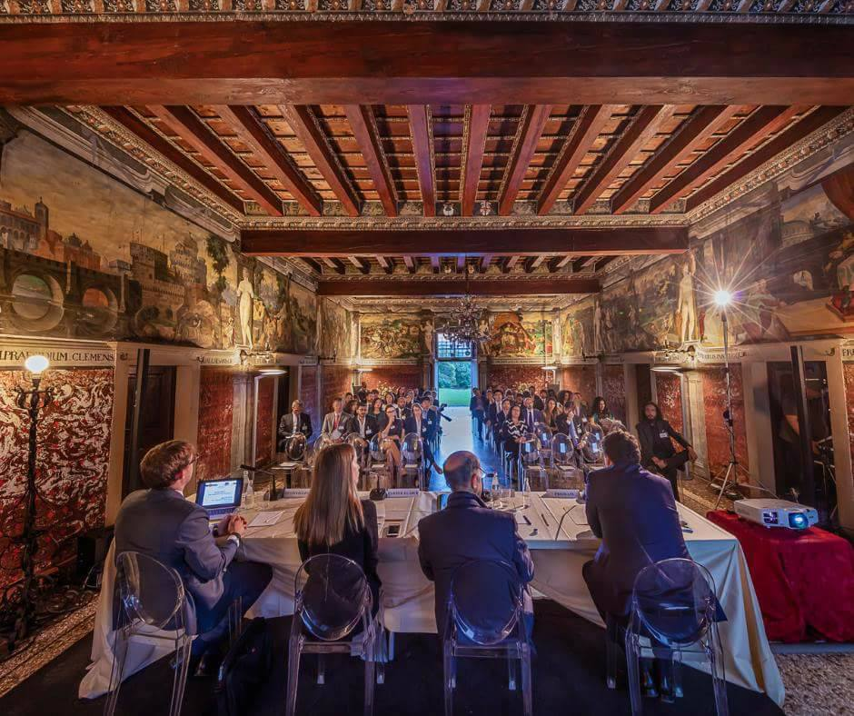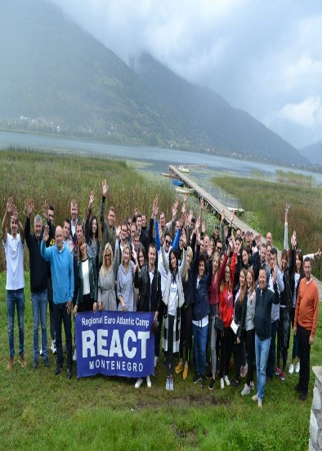

Academic publishing

Daskalovski Zhidas, “EU enlargement and geopolitical struggles- the influence of the regional powers in the Balkans” in Svetlana Nikoloska and Angelina Stojanoska (eds.) Security, Political and Legal Challenges of the Modern World, University of “St. Kliment Ohridski”, Bitola, 2018;
Daskalovski Zhidas, “Security dilemma: border changes to achieve ethnically “pure” states or management of minority rights,” in Marjan Gjurovski (ed.), Security, Regional Cooperation and Reforms in Kosovo and Macedonia, Konrad Adenauer Foundation, Faculty of Security, University of “St. Kliment Ohridski”, AAB College, Skopje 2018;
Tamara Dimitrijevska-Markoski “Assisting Media Democratization after Low-Intensity Conflict: The Case of Macedonia” in Tarik Jusić and Kristina Irion (eds.) Media Constrained by Context, International Assistance and the Transition to Democratic Media in the Western Balkans, CEU University Press, 2018.
Daskalovski Zhidas, “Makedonija i bezbednosta vo regionot: slabata drzava kako bure barut [Macedonia and the security of the region: the weak state as a powder keg], in Politichka Misla, Vol. 16, N.55. 2018.

2. CRPM policy research and analysis work
CRPM managed to maintain the reputation of being a leading Macedonian think tank offering original, excellent quality studies and briefs. The organization developed different products such as policy studies, policy briefs that are following the internationally accepted standards, but CRPM focused on the context and environment in Macedonia.

2.1.Macedonianpolitics

2.1.1. School of Public Policy “Mother Theresa”
The School had regular activities in 2018, weekly discussions and three weekend seminars The School of Public Policy Mother Teresa finished activities for the Generation of Students 2017/8 in May. At the end of June, the Generation of Students 2018/9 started their activities with the weekend session focused on Public Policy Analysis in Theory and Practice. Liberal Multiculturalism and Public Policy: from Theory to Practice was a topic of another weekend session, while we also discussed Issues in Euro-Atlantic affairs and enlargement.
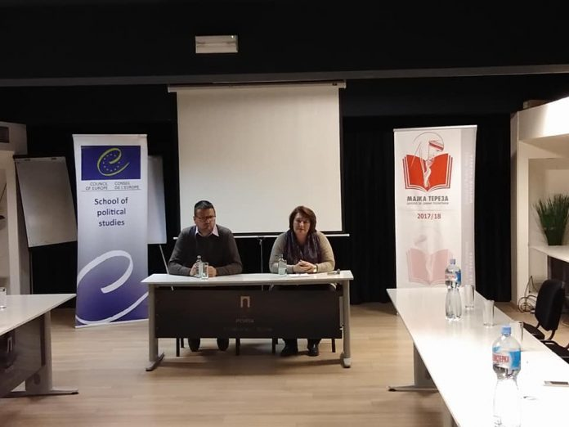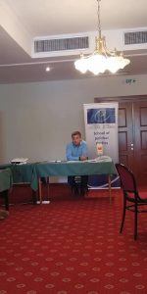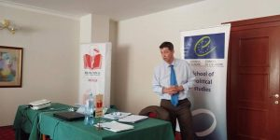
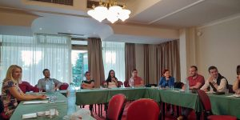
In principle the School lasts from October to June and typically offers: four weekend courses, CRPM discussions and a World Forum for Democracy at the Council of Europe. The weekend courses have an intensive program of lectures, workshops and debates. The CRPM discussions are offered by eminent persons whose introduction of 22 minutes and 22 seconds is followed by Chatham House rule discussion on topics related to the themes of the School. In November, our students participated at the World Forum for Democracy. The Strasbourg World Forum for Democracy is an annual gathering of leaders, opinion-makers, civil society activists, representatives of business, academia, media and professional groups to debate key challenges for democracies worldwide.
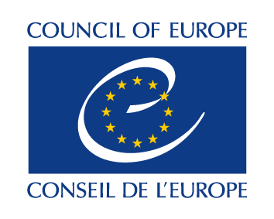
Funded by: Council of Europe

2.1.2. Youth mobility

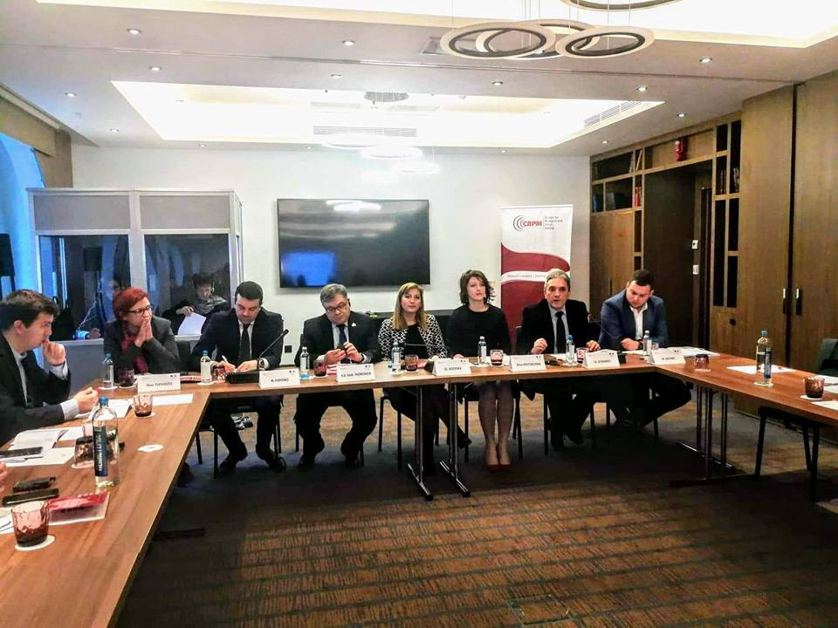
CRPM's newly established cooperation with the French Embassy in Skopje led to a research idea on the link between the European integration, specifically the European mobility programmes and the brain drain of young people from the country. CRPM conducted a survey targeting young people at the age between 15 and 19 and a series of interviews with representatives of the Macedonian policy makers. The analysis of the collected data was published and presented in the form of a study "European integration and youth mobility: from brain drain to brain gain". In addition, a high-level round table was organized with the participation of the Deputy Minister for Education, the DIrector of the National Agency for Youth and Sports, the President of the Club of Young MPs and the President of the National Council for European Integration in the Macedonian Assembly.

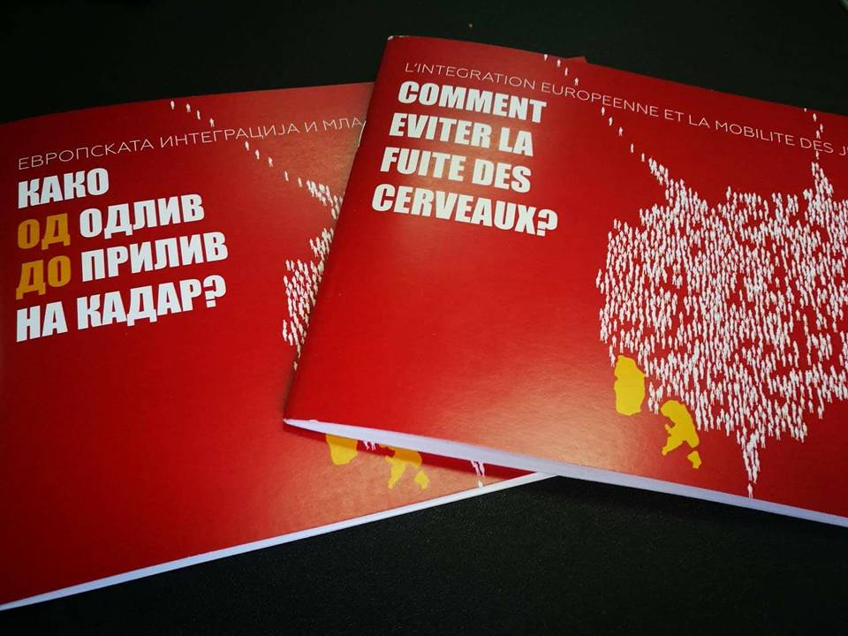

2.1.3. Strengthening MOIA’s Structure and Capacity to Deal with transnational Threats with Special Attention to Fight against Organized Crime Including Support to the Border Affairs Management – Phase III
CRPM in partnership with OSCE has organized five one day roundtable discussions with the National Committee for Countering Violent Extremism and Counter-terrorism (NCCVECT) on the Strategy for countering violent extremism – CVE with local stakeholders: municipal administration, local institutions, religious communities, CSOs, social workers, youth, teachers, and other community leaders. The roundtables were held in Skopje, Struga, Tetovo, Gostivar and Kumanovo. The discussions aimed at awareness raising among the community on the CVE strategy and to internalize the possible activities local stakeholders could plan and implement in the framework of implementation of the National strategy for CVE.
Partner: OSCE

2.2. Good governance

2.2.1. Rule of law

From April to November 2018, CRPM together with the Group for Legal and Political Studies from Prishtina has implemented a research project “Developing methodology for assessing the rule of law in Kosovo and Macedonia based on the CoE’s Rule of Law Checklist”. The project was financially supported by the Konrad Adenauer Stifftung Regional Office in Bucurest. The main output of the project activities were the two assessment reports of the rule of law in Kosovo and Macedonia, based on the jointly developed methodology by the project partners. The findings of the report show that rule of law indicators in Kosovo were average fulfilled as 54.2%whilst in Macedonia the average fulfillment was 66%. The result from the research were presented on a final event in Pristina, before the representatives of CSOs, academia and international organizations from Kosovo and Macedonia.
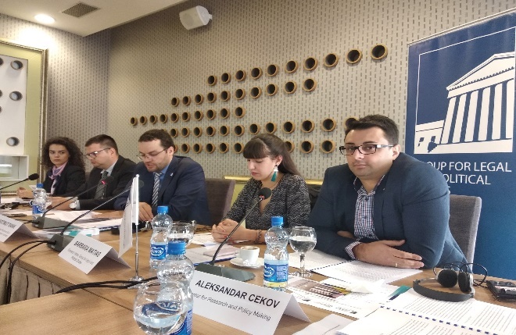
Funded by: KAS

2.2.2. Index for Youth Development in Macedonia

The Center for Research and Policy Making was contracted to develop an Index for Youth Development in Macedonia for the Coalition of Youth organizations SEGA from Prilep. The methodology was developed on a basis of Global Index for Youth Development. It contained 5 categories relevant for the youth development. Employing the Index, as assessment was conducted to examine the situation in the 8 planned regions, by focusing and collecting data for selected municipalities from the regions. Thus, a baseline study was produced with an aim to help youth organizations to advocate for change before the decision makers. The Index presents the result through a band scores in different categories in order to offer comparable data to take into account the changes over 2 year period of time. The findings of the report were presented on a final event on 18.12.2018.
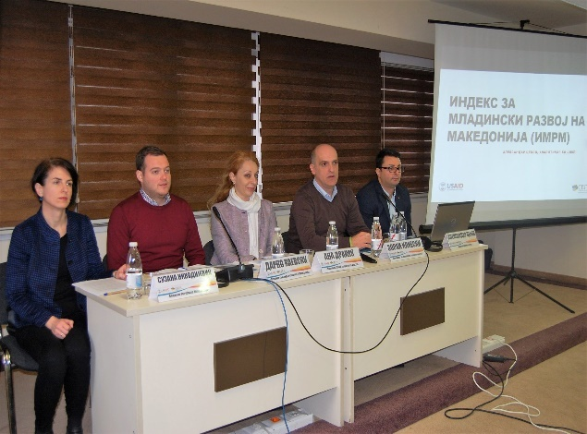

Funded by: USAID CEP / Coalition SEGA

2.3. Labor

The Adaptation of Industrial Relations towards New Forms of Work

The Center for Research and Policy Making in cooperation with five partner organizations from Bulgaria, Poland, Romania, Croatia and the Czech Republic is implementing the project ‘The adaptation of Industrial Relations towards new forms of work’, supported by the European Union.
The Fourth Industrial Revolution, also known as the Digital Revolution is currently changing not only the human interactions, but also work-related interaction. In the context of technology’s evolution, labour market has considerably changed over the years, reshaping work relationships between employees, employers and their representatives, as well as working conditions, job skills requirements and overall job creation and job losses. New forms of employment pose serious challenges to the existing regulatory system of both labour taxation, but also social protection, balance of professional and private life etc. Within this project CRPM documented the scope and potential of development of new forms of employment and the digital economy in the Republic of Macedonia, while putting the research in a context of the need for the traditional industrial relations main stakeholders (trade unions, employers organizations, state institutions) in order to adjust the national legislation and to identify the triggers for adaptation. We have noted that part of the new forms of employment can be applied with certain changes in the legal framework in order to increase the flexibility in the relation between workers and employers, as well they can contribute in reducing the undeclared work. Also new forms of employment have the potential to increase the employment of those in disadvantaged groups in the labour market (mothers returning from maternity leave, people with care responsibilities, older, disabled or sick people and people in education).
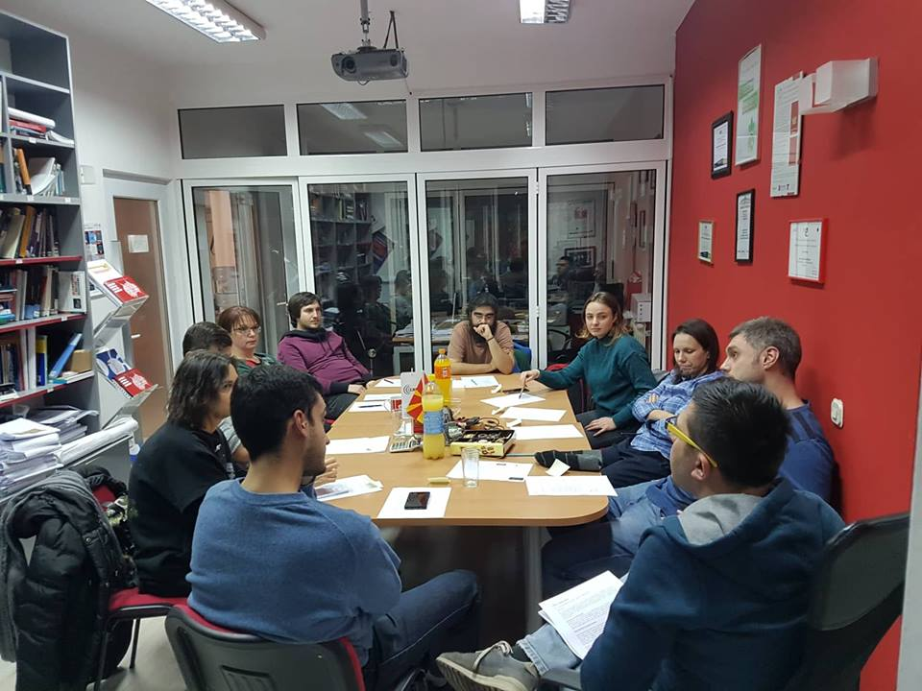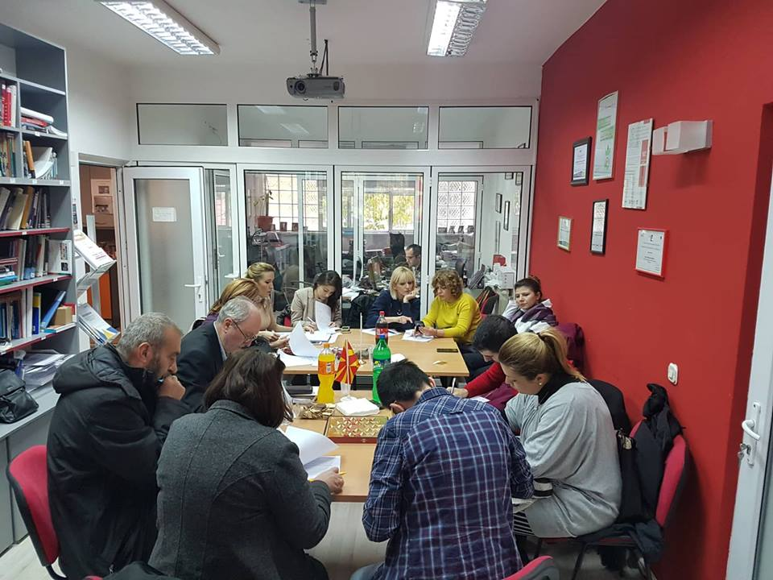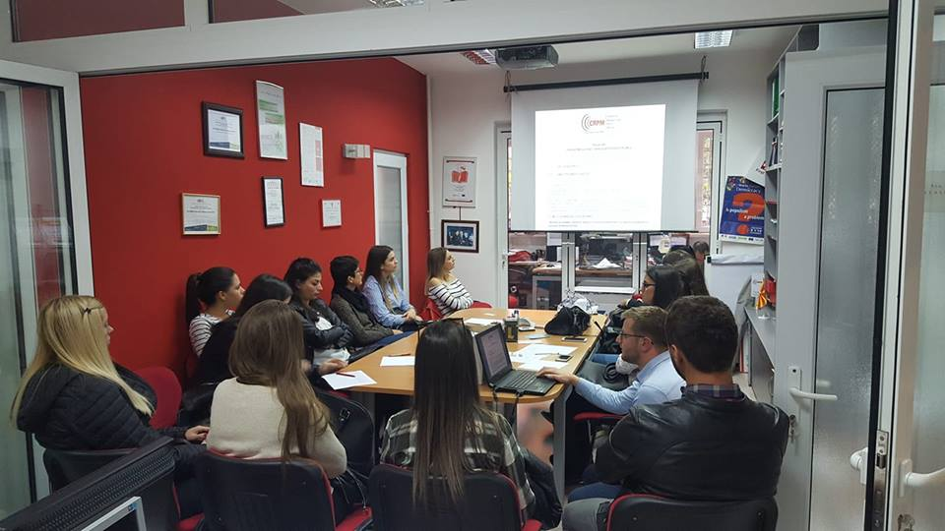
Funded by: European Union

2.4. Education

2.4.1. E2P
CRPM, together with two partners implemented couple of components within the “Educate to Prevent - Strengthening Front-line School Workers and Parents to Build Youth Resilience to Violent Extremism” project. For the period to which this report refers, the implementation of the project is more than satisfactory. As an overview, the Educate to Prevent (E2P) action is the first large project tackling issues such as prevention of radicalization leading to violent extremism in Macedonia. In this first period of implementation of the project, the project consortium led by CRPM managed to successfully implements the planed project activities. Furthermore, fruitful partnerships were built with numerous stakeholders such as the National Committee for Countering Violent Extremism and Countering Terrorism (NCCVECT), the ministries of education and internal affairs, as well as with the eight municipalities within the three regions where the activities are implemented. Lastly, synergies were built with the OSCE Mission to Skopje (OSCE MtS) and the International Organization for Migration (IOM). The traditionally good relationship with state institutions was also upheld, in particular with the Ministry of Education (MoE) and the Bureau for Development of Education (BDoE).
In regards to the achievement of the outcomes, the project managed to secure baseline information and learn the training needs of the frontline school workers. Furthermore, the project consortium started with the trainings of frontline school workers, municipal officials and parents in order to enable them to recognize early signs of detection. What refers to the strengthening of the municipalities’ capacities to establish an early warning mechanism, this outcome is in the process of completion and will be achieved by the end of the action implementation phase. Lastly, the advocacy for institutionalization of the system for early detection of cases of radicalization is in its initial phase, but will be timely completed by the end of the project.
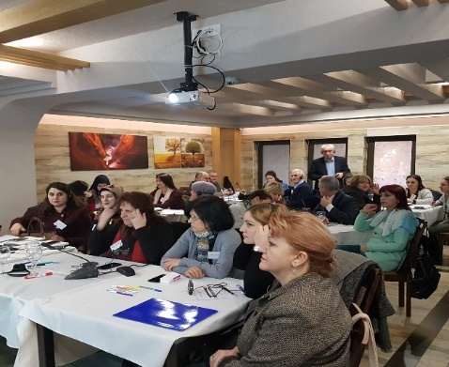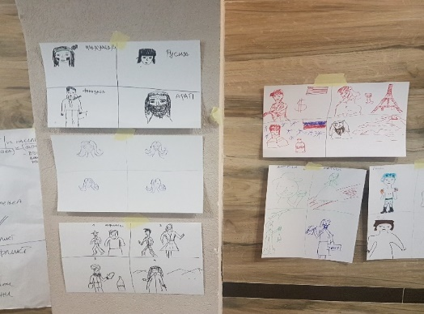
Financed by: EU Strive Global Program

2.4.2. Learning to learn skills

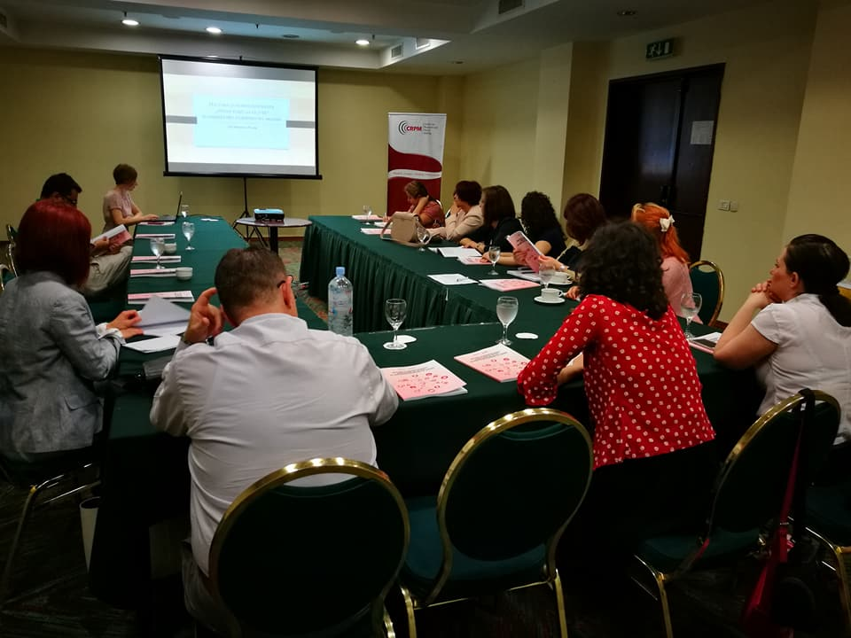The Center for Research and Policy Making has completed the research study ‘Teaching Learning to Learn Competence for the Knowledge-Based Society’. Findings of the study were disseminated on June 21st, in Skopje. 15 stakeholders participated at the event, representing education policymakers (Bureau for Development of Education (BDE), State Examinations Center), NGOs (Step by Step, MCEC), international organizations (UNICEF, Open Society Foundation), school teachers and support staff and independent consultants. They expressed great interest in the findings of the study and contributed in further elaborating the recommendations. The representative of the BDE noted that he will recommend adding training on LtL supporting instructional methods in the list of trainings which teachers can choose from during their in-service education. Numerous additional stakeholders, which could not attend the presentation, expressed interest in the study findings. The full study was sent to them, as well as to about 100 relevant stakeholders, in electronic version.

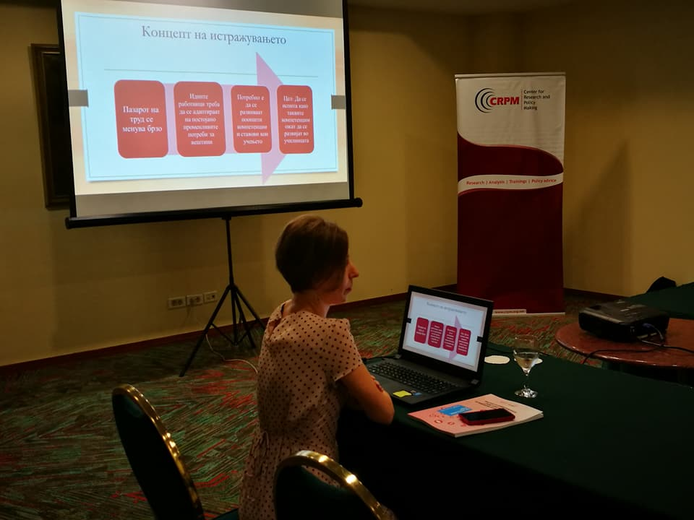

Funded by : GDN

2.5. Gender

GRB watchdog reports
CRPM continued the fruitful cooperation with UN Women in the area of Gender Responsive Budgeting by implementing the second cycle of the project Enhancing the capacities of civil society organizations to prepare gender budget watchdog reports on the local level. Through a workshop and mentoring sessions, 10 CSOs drafted 15 GRB reports on 14 different municipalities and in 9 different programmes/areas. Finally, CRPM organized a workshop that had an objective to exchange knowledge and experience between CSOs from Macedonia, Moldova and Albania on gender budget watchdog reporting; to inform and increase capacity and knowledge base on the Macedonian policy and institutional system for gender quality; to become acquainted with the gender budget watchdog work of Macedonian CSOs and their cooperation with local level government in developing gender responsive policies and budgets; and finally to initiate a community of practice between gender budget watchdogs from Macedonia, Moldova and Albania.
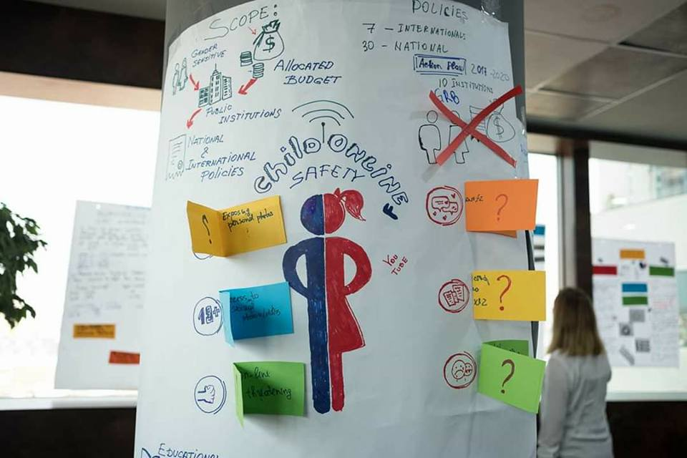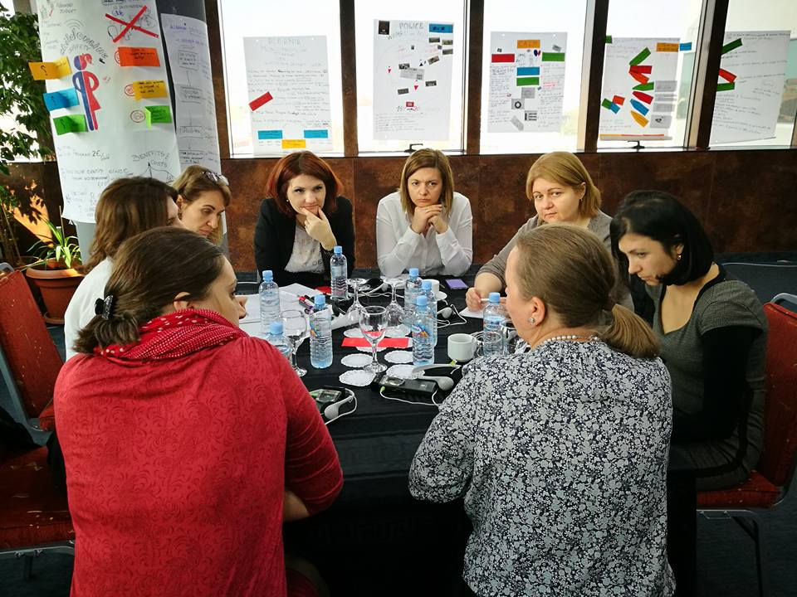
Funded by: UN Women project “Promoting Gender Responsive Polices in South-East Europe and the Republic of Moldova” (2017-2018)” financed by the Austrian Development Agency and the Swiss Agency for Cooperation and Development

Advocacy and expertleveldialogue with Government and Parliamenttoamendexistinglegislation in the field of genderbasedviolence and genderbaseddiscrimination, in line with internationalstandards, humanrightsmechanismsrecommendations (UPR, CEDAW, CAT, CERD, CCPR, CESCR), EU Directives and IstanbulConvention
In partnership with the Macedonian Women’s Lobby, CRPM has been implementing the project funded by the UN Women, which objective is to provide support of the process of implementation of the Istanbul Convention in Macedonia. The project activities encompass two types of activities: research and advocacy. Within the first type of the activities, main product is the gap analysis which will proved a clearer picture on what should the process focus on, based on the gaps between the requirements of the Istanbul Convention and the actual state of affairs in the Macedonia related to the protection victims from the gender based violence. The second phase of the project will include advocacy and expert level dialogue to provide support of the process of implementation.
Funded by: EU funded project implemented by UN Women

Pre and post survey
The goal of the project was to prevent discrimination and violence against women through better understanding of current and dominant attitudes related to gender equality and gender-based violence as well as the factors that influence them at community level. In this regard, conducting a field survey on a nationally representative sample was the first step in assessing the perceptions, attitudes and values of men and women in the country and the factors they correlate with. For this purpose, CRPM conducted public survey on representative sample of 600 responders. In order to acquire in depth understanding on the situation on the ground, CRPM also conducted 14 in-depth interviews with civic organizations working on GBV, as well as municipalities and central government bodies. Additionally, we organized 5 focus groups with victims of domestic violence, lawyers who work on these issues as well as civic activists. All of the data was systematized in excel and SPSS format and delivered to the external expert who is currently in the final stage of developing base line study upon which a new approach for designing the future advocacy campaigns on national level will be tailored. In order to use the collected data for initial advocacy purposes, CRPM developed four infographics on the respective topics a) Perception and awareness on the existing legislation; b) General perception regarding gender based violence; c) Exposure to violence prevention messages; d) Attitude towards changing/improving GE and VAW&DV issues in the future;.
Funded by: EU funded project implemented by UN Women

3.6 Sustainable development

Regional cooperation and competence development of parliamentarians of South-East Europe on energy efficiency, climate topics and urban mobility

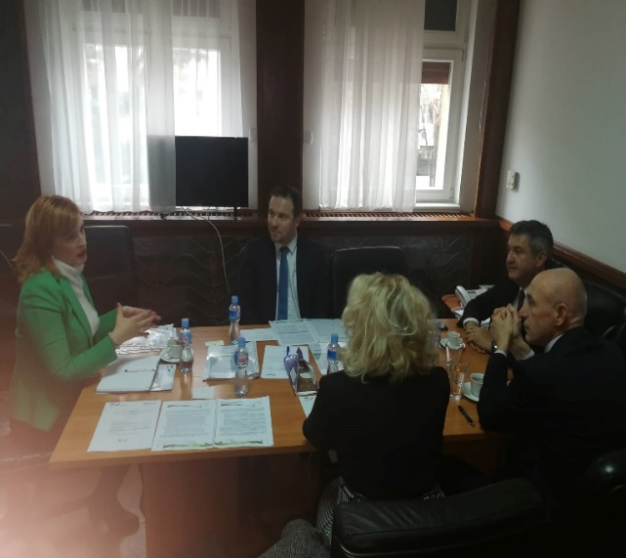This project has three main goals: (1) Enhancing the parliamentarian dialogue on a national level of energy efficiency, urban mobility and energy poverty policies as well as on necessary reforms that will eventually be undertaken after the opening of the EU accession negotiations; (2) Strengthening the cooperation and communication between the legislative and executive authorities about the necessary reforms and steps that need to be taken in order to improve Macedonia’s national energy efficiency and climate change mitigation portfolio; (3) Strengthening mutual trust among MPs and NGOs (primarily CRPM) as reliable partners. In 2018, CRPM organized Initiating preparatory meeting with interested MPs for two purposes - the first one was to advocate to establish Green group in the Macedonian Sobranie (in a framework of other GIZ project, supported by GIZ – ORF Biodiversity Serbia) as well as to familiarized them with the main activities and their involvement in regards to the project. Afterwards, CRPM in collaboration with external expert developed a White paper. The document presents the road map that Macedonia needs to fulfill during the negotiations process with EU in regards to the climate change, renewables and the energy efficiency with final aim to improve its national portfolio in these areas. It is reader friendly document that will help the MPs and the parliamentarian staff in their future efforts in joining drafting policies, holding the governmental officials accountable for their work. The document was presented to the relevant MPs in October, 2018, while in the course of November and December was boosted on Facebook in order to familiarize the general public on the current situation in Macedonia as well as the necessary actions that need to be taken in the upcoming period.

Funded by: GIZ – ORF EE

Smart Start: Sustaining civil society impact through social entrepreneurship and innovations in Bosnia and Herzegovina, Serbia, Montenegro, Macedonia and Turkey
In the course of 2018, CRPM was focused on the advocacy camping as well as monitoring the work of the 10 sub granted social enterprises. . In 2018, we have organized 8 on post visits and discussed with the sub grantees ongoing challenges and modules for improvement during implementation of their business plans. In addition we have organized 6 mentorship meetings with the respective sub grantees and mentors. CRPM in the course of the reporting period delivered 5 policy papers as well as 5 policy memos, depicting the state of affairs in Bosnia and Herzegovina, Serbia, Montenegro, Macedonia and Turkey on the social entrepreneurship environment, both legislative and practical. We also organized the Social Innovation Competition 2 after which by the votes of the general public, it was decided that Konedu Global with their idea “Learning can be fun” deserves the fund of 3.500 €. The main idea is this - a core group of teachers will be created who are willing to invest their time and knowledge. Through workshops, they will be trained on the process of developing educational applications including conception, design, programming (coding), linking to the objectives of the curriculum and drafting a manual for use and publication of the apps. The principle of universal design will be applied. The benefits will be used by the students, but also the teachers who will be using the apps and will be also able to adjust them on the basis of the interest and ability of their own students. Regarding the advocacy campaign, we made several TV appearances as well as interviews on web portals. All of the efforts were aiming at enabling environment on establishing and running social enterprises in Macedonia, promotion of the SMART START Hub and the SMART Start project as well as promotion of the 10 sub grantees and 2 SICs.
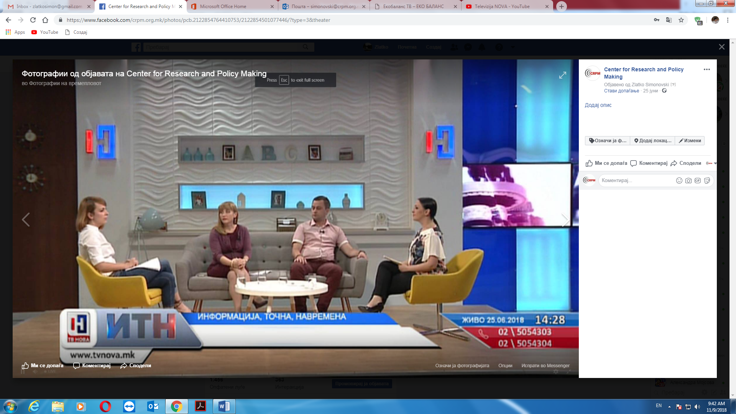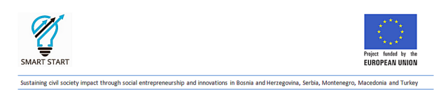

RIRA
With the support of the Regional Cooperation Council, CRPM became the first think tank in the Western Balkans to engage in an area thus far reserved for the national authorities and the business community - investment policy. The regional project Invigorating Policy Dialogue on the Regional Investment Reform Agenda (RIRA) initiated close cooperation between these three stakeholder groups in order to improve the development and the implementation of RIRA in the 6 Western Balkan economies. It consisted of 6 national information sessions - Open Days in the 6 capitals, 2-day capacity building workshop for civil society organizations and business associations from the 6 economies organized in Skopje and a regional RIRA high level Forum organized in Skopje on 28 November. The project also produced a policy paper identifying the challenges and opportunities related to RIRA and a Joint Declaration on RIRA's further implementation throughout the Western Balkans.
Funded by: European Union through Regional Cooperation Council - RCC

4. CRPM events

World Forum of Democracy
The 2018/2019 generation of the CRPM School of public policy Mother Theresa is in Strasbourg for the World Forum for Democracy. The Forum is hosted by the Council of Europe and brings together members of civil society, political leaders and representatives of business, academia, media and professional groups from more than 47 states.
The World Forum for Democracy 2018 is dedicated to gender equality and women’s rights. We will focus in particular on women’s public, political and economic participation and on combating violence against women in the wake of #MeToo. The Forum takes place in Strasbourg from 19 to 21 November 2018.
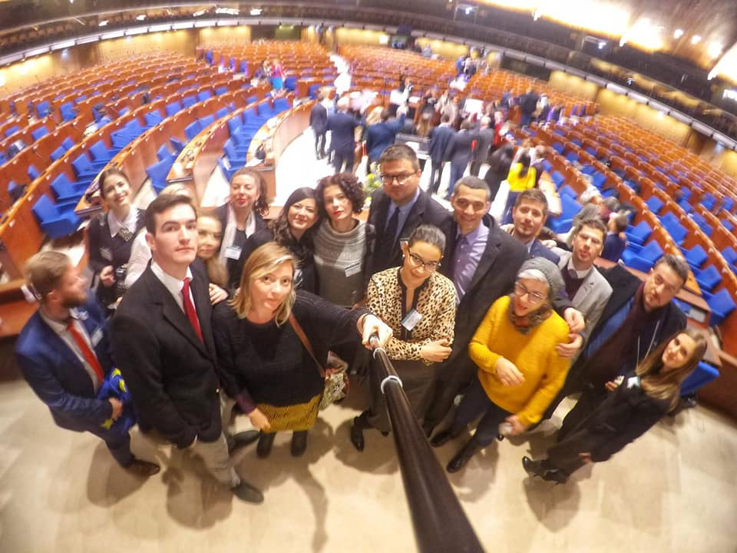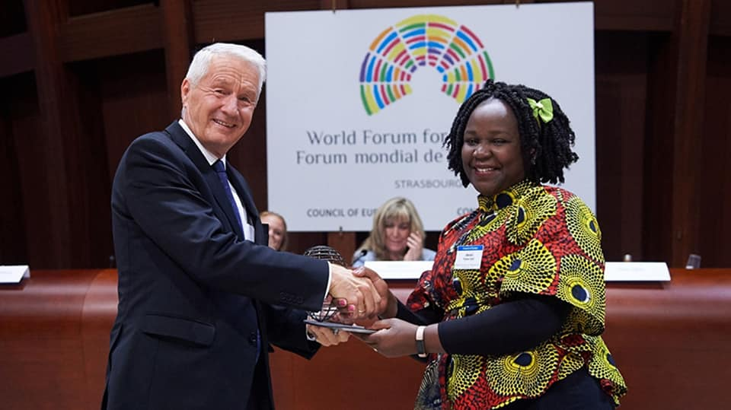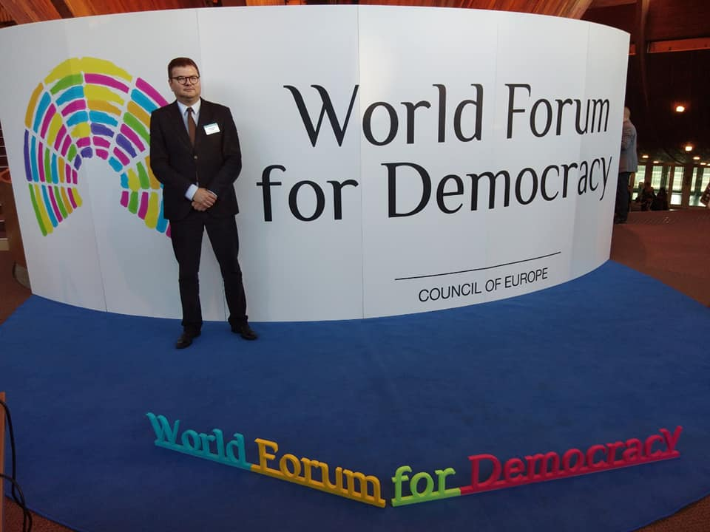
Partner: Council of Europe

RIRA forum

Improving the competitiveness of the region by harmonizing the investment policies of the economies of the six Western Balkan countries with EU standards and best international practices, strengthening public-private dialogue, and involving all relevant factors in the decision-making process are part of the conclusions of the first policy forum on the Regional Investment Reform Agenda (RIRA) for the Western Balkans.
Goran Svilanovic, Secretary General of the Regional Co-operation Council (RCC) stressed that the successful implementation of the RIR Agenda is a chance for the Western Balkans to be accelerate their EU integration process. “An integrated approach to investors is needed. Acting as a single market, the opportunities for attracting large and serious investors are greater,“ said Mr. Svilanovic
Marija Risteska, Executive Director of the Center for Research and Policy Making, emphasized that greater openness is needed of the investment policy-making process and cooperation between all parties in the process should be enhanced in order to create better investment policies on the national and regional level that will create benefits and value for the citizens and the businesses.
At the end of the forum, a Declaration was adopted by the representatives of the civil society organizations and business community that can be found at the following link.

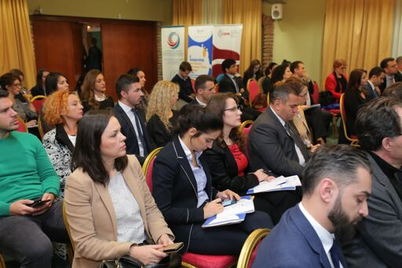
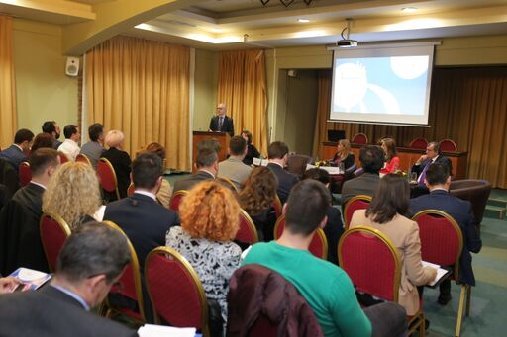
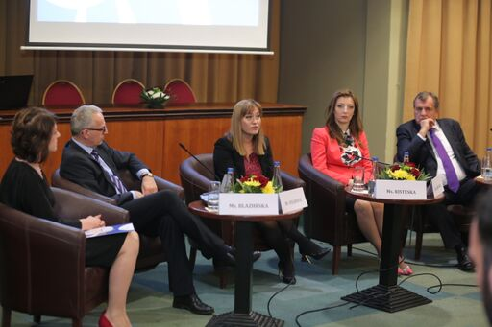

Partner: RCC

CEI Hidden Economy Forum
With the assistance of The Balkan Trust for Democracy and the Central European Initiative, the Center for Research and Policy Making (CRPM) organized a Regional Hidden Economy Forum on the 6th of February, 2018 in Hotel Holiday Inn- Skopje. The event brought together stakeholders and policy makers from the region to discuss the findings from the Comparative Hidden Economy Monitoring Study, which analyzes the spread and trends of hidden economic activities in Macedonia, Albania and Kosovo, and was prepared in cooperation with the Institute for Democracy and Mediation from Albania (IDM) and Democracy for Development (D4D) from Kosovo.
The Policy Forum was opened by the Director of the Public Revenue Office in Macedonia, Ms. Sanja Lukarevska; the Deputy Minister of Social Welfare from Kosovo, Mr. Cerkin Dukoli and Mr. Nikolla Lera, General Director of Macroeconomic and Fiscal Policies and Employment, Ministry of Finance and Economy, Albania. They all stated their support for the project recommendations and expressed openness to incorporate them in the national policy agenda. In addition, some of the leading experts on monitoring hidden economy from the region – Mr. Josip Franic (Croatia), Mr. Todor Yalamov (Bulgaria) and Ms. Blagica Novkovska (Macedonia) participated as key note speakers.
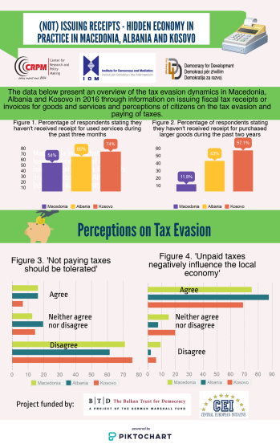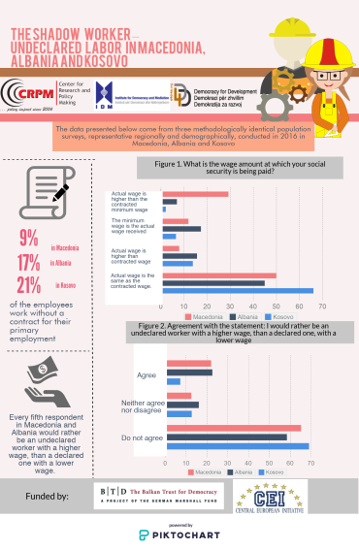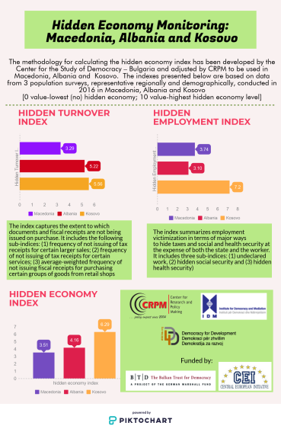

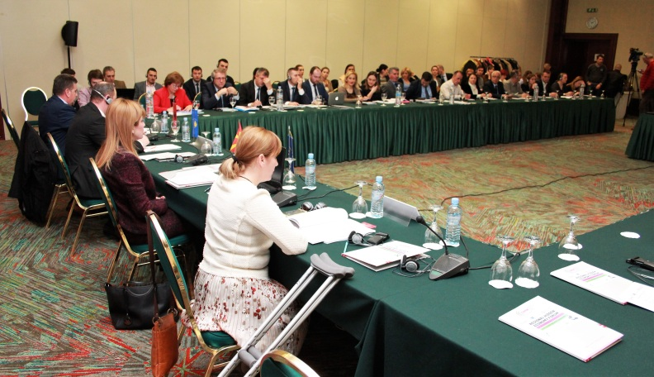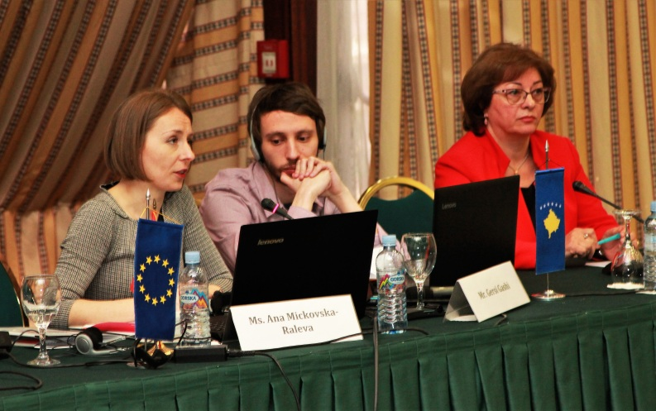

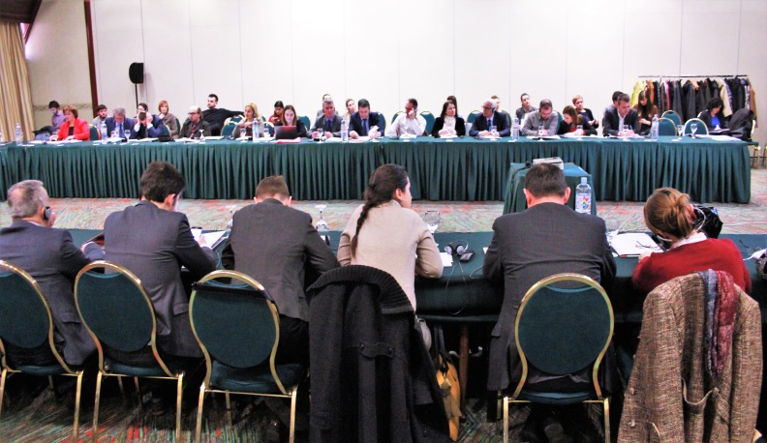

Partner: BTD and CEI

5.Outputs/ Results:

5.1.Books
CRPM did not publish books in the course of 2018

5.2.Media
- Што добива Македонија и дали ни е потребно брзо интегрирање во ЕУ – анализа во Студио 1. Гостување на Марија Ристеска на 1 TV. 19/09/2018 Линк;

- Одливот на млади од РМ. Гостување на Ана Крстиновска на Отворено студио, 1ТВ. 05/12/2018 Линк;

- Деценискиот спор пред разрешница? Гостување на Марија Ристеска на Отворено 24. 22/05/2018 Линк;

- Преку социјално претприемништво до развиени заедници. Интервју на Марија Ристеска за портал Иновативност. 26/12/2018 Линк;

- Зошто токму сега ЕУ ги решава споровите на Балканот?, Гостување на Ана Крстиновска на Respublika, 01/08/2018 Линк;

5.3.Policy briefs
Од подобра правнарамка кон растечка класа на социјални претприемачи во Mакедонија - http://www.crpm.org.mk/wp-content/uploads/2018/09/Socijalni-pretprijatija-MK4-2.pdf
Социјално предузетништво у Cрбији у порасту– бољи услови за бржи развој - http://www.crpm.org.mk/wp-content/uploads/2018/09/Socijalni-pretprijatija-SRB4-1.pdf
Socijalno preduzetništvo u Crnoj Gori – nova rješenja za bolji rezultat - http://www.crpm.org.mk/wp-content/uploads/2018/09/Socijalni-pretprijatija-MNE2.pdf
Pametan razvoj kroz društveno preduzetništvo u Bosni i Hercegovini
http://www.crpm.org.mk/wp-content/uploads/2018/09/Socijalni-pretprijatija-BIH4-1-1.pdf
Türkiye'de sosyal girişimcilik için sürdürülebilir bir ortam yaratmak
http://www.crpm.org.mk/wp-content/uploads/2018/09/Socijalni-pretprijatija-TR4.pdf
Бел документ - Предизвиците и задачите во поглед на поглавјата 15 и 27 од правото на Европската Унија
http://www.crpm.org.mk/wp-content/uploads/2018/11/Bel-dokument-ver10.pdf
Regional Investment Reform Agenda – creating regional partnerships, enhancing national development Policy analysis of the Regional Investment Reform Agenda in the Western Balkans
http://www.crpm.org.mk/wp-content/uploads/2018/11/RIRA_Brochure_body_WEB.pdf
Европскаtа интеграција и младинската мобилност: како од одлив до прилив на кадар?
http://www.crpm.org.mk/wp-content/uploads/2018/12/Brochure_Youth_A5_MK_WEB.pdf

5.4. Policy Studies

The rule of law in Macedonia

http://www.crpm.org.mk/wp-content/uploads/2018/12/The-Rule-of-Law-in-Macedonia.pdf

The rule of law in Kosovo
http://www.crpm.org.mk/wp-content/uploads/2019/01/FINAL-Kosovo_THE-RULE-OF-LAW-CHECKLIST.pdf
Teaching ‘Learning to Learn’ competence for the knowledge-based society available in Macedonian and English language on the following links:
http://www.crpm.org.mk/wp-content/uploads/2018/11/Teaching-Learning-to-LearnEN-color.pdf
http://www.crpm.org.mk/wp-content/uploads/2018/11/Teaching-Learning-to-LearnMK-color.pdf
Monitoring the Hidden Economy in Macedonia, Albania and Kosovo: Trends, Policies, Options (2016-2017)
http://www.crpm.org.mk/wp-content/uploads/2018/02/Studija-Monitoring-EN.pdf?fbclid=IwAR1LQ8pMGo7J9JvSX8am3OynP178fml9qdmPPX0qDWEyAlvp1J3JY5O5_KQ
http://www.crpm.org.mk/wp-content/uploads/2018/02/Studija-Monitoring-MK.pdf

5.5. Policy initiatives

Quality management system for CSOs
The Center for Research and Policy Making has submitted an initiative before the Institute for Standardization of the Republic of Macedonia to register our Quality Management System, developed by the CRPM and the organizational expert Elizabeta Markovska Spasenovska. This initiative seeks to offer Macedonian CSOs authentic contextual based Quality Management System which was created in participatory manner, with contribution of Macedonian CSOs, especially those which offer social services.
On the last meeting held on 20.12.2018, the Technical Committee which processes the initiative approved the initiative and recommended further steps to be taken towards registering the Quality Management System.

Gender Responsive Budgeting in Public Finance Management
In the context of the European integration process and more sound management of public funds, the Republic of Macedonia adopted a Public Finance Management Programme which envisages, inter alia, amendments to the Organic Law on Budgets. In line with CRPM's mission to promote gender equality, we engaged in a policy advocacy initiative to use the amending procedure in order to integrate Gender Responsive Budgeting (GRB) as a principle in the Law. We believe that this is a precondition to streamline GRB through the public institutions in order to align their budgeting and spending procedures with the best practices and in service of both men and women.

II. Financial report 2018
BALANCE OF REVENUES AND EXPENDITURES FOR PERIOD
01.01.2018-31.12.2018

