SCHOOL OF PUBLIC POLICY |MOTHER TERESA| INDIVIDUAL LECTURES AND DEBATES
Period: September 2017 – June 2018

142. Lecture: "Challenges and Opportunities in policy making in Macedonia"
Speaker: Prof. Biljana Vankovska

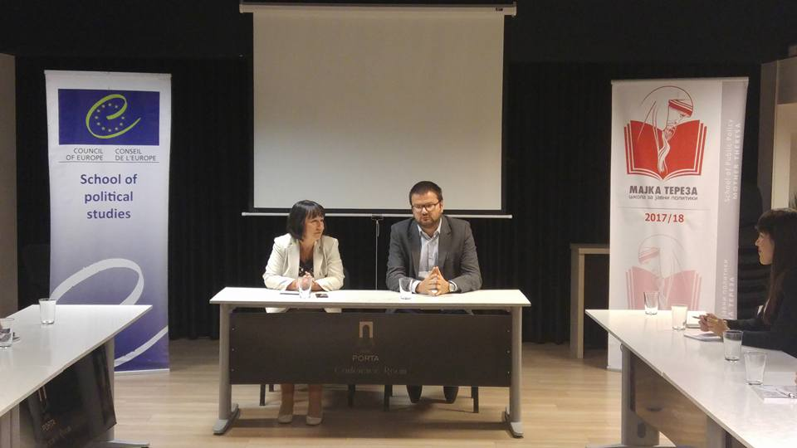

143. Lecture: "EU and the democratic challenges for policy making in the Balkan region"
Speaker: Nicola Bertolini, Head of Cooperation, EU Delegation in Macedonia
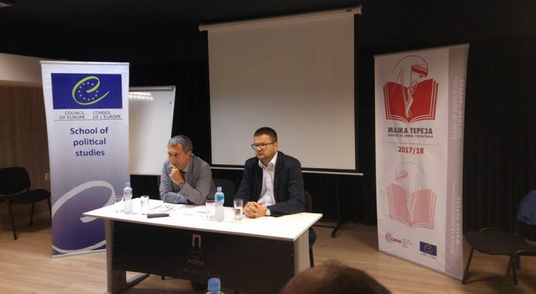
144. Lecture: “The refugee/migrant crisis and the policy response of Macedonia”
Speaker: Sinisha Aleksoski, Adviser on Security to the President of Macedonia, Mr. Gjorgje Ivanov
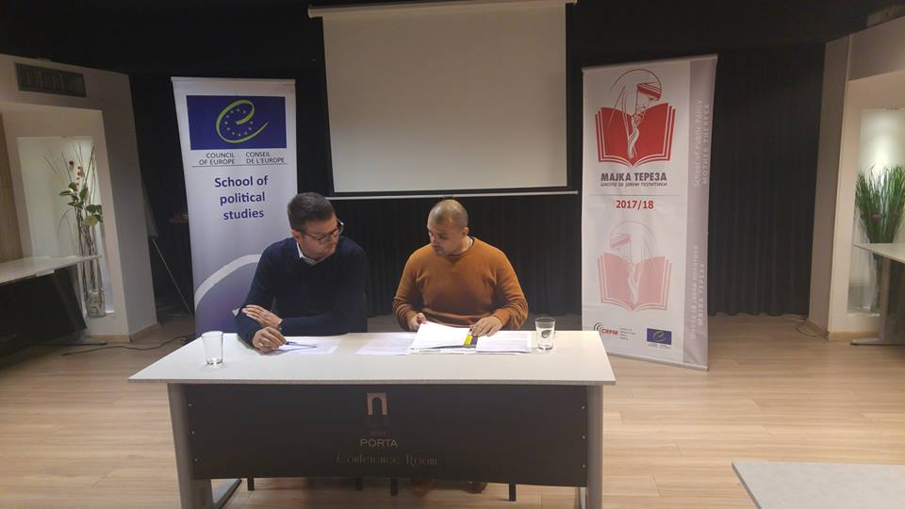

145. Lecture: “Gender-sensitive policies – is there a change after 20 years of independence”
Speaker: Dijana Stojanovic Gjorgjevic, PhD, Kvinna till Kvinna Foundation
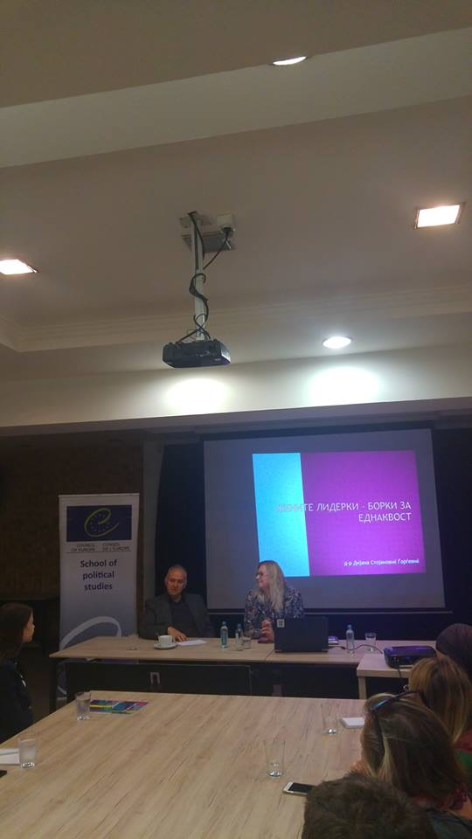

146. Lecture: “China’s Belt & Road Initiative: A Perception from the Balkans”
Speaker: Anastas Vangeli, Doctoral Researcher at the Polish Academy of Science, and PhD Fellow at the ZEIT Stiftung
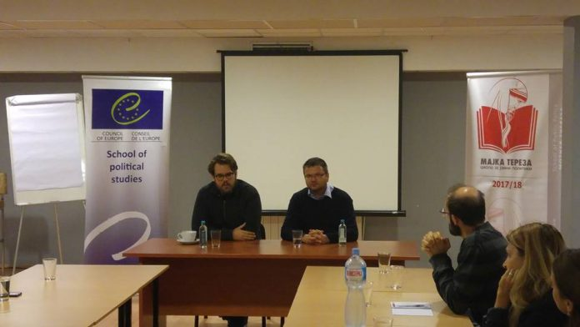

147. Lecture: “Feminism in the XXI century”
Speaker: Ana Vasileva, feminist
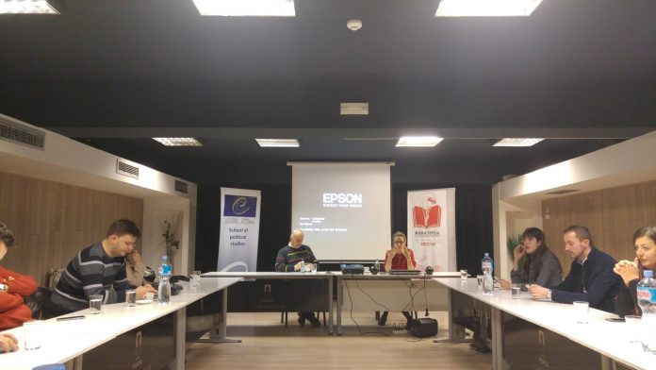

148. Lecture: “Good governance and informality”
Speaker: Nenad Markovikj, PhD, Professor of political science at UKIM, Skopje
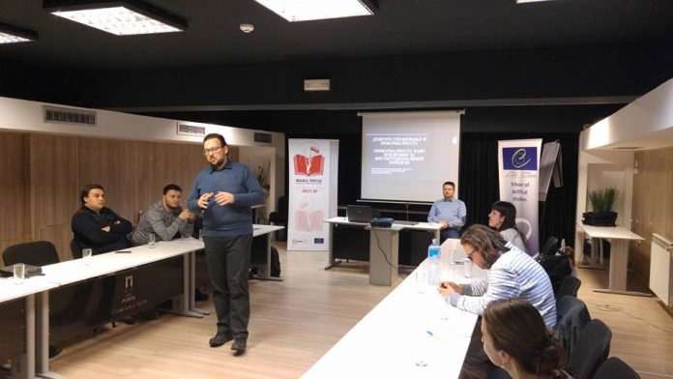

149. Lecture: “Plagiarism in Higher Education”
Speakers: Kire Babanoski, Daniel Gjokeski, Katerina Klimoska, Biljana Dukoska, School Alumni
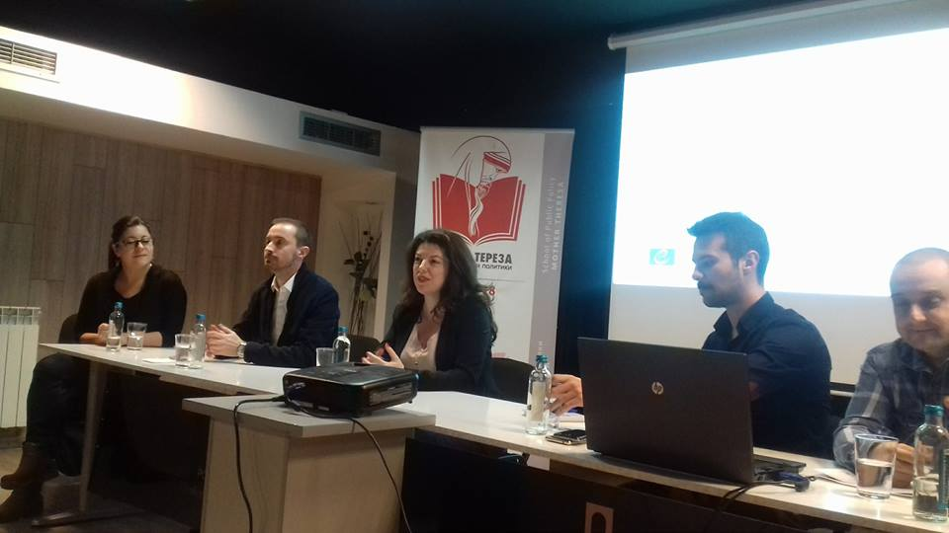

150. Lecture: “The Berlin Process and reconciliation: the need of establishing REKOM”
Speaker: Natasha Kandic, human rights activist, regional coordinator of REKOM
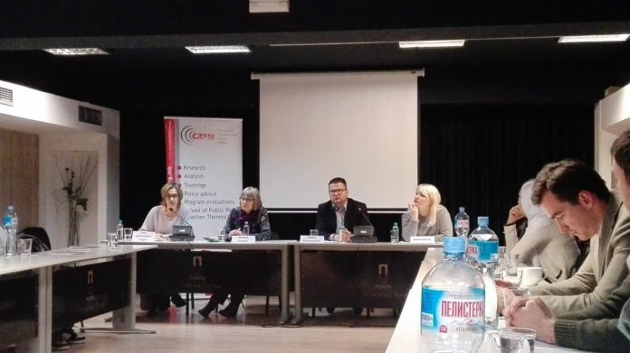

151. Lecture: “Management of human resources in political parties
Speaker: Tanja Tomic, MP
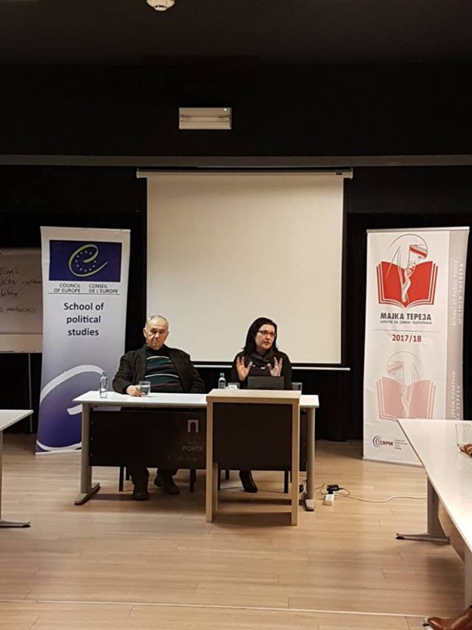

152. Lecture: Micro-targeting: invasion of private data, instrument for influence of the electorate, instrument of influence on democracy and/or propaganda tool?
Speaker: Ljubica Pendaroska, expert on intellectual property
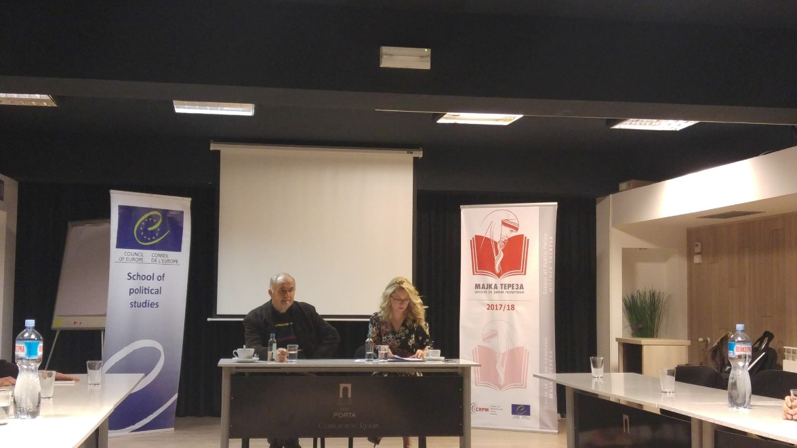

153. Lecture: European Court of Human Rights: Topical Cases and Importance for Public Policy
Speaker: Mirjana Lazarevska Trajkovska, Former Judge at European Court of Human Rights
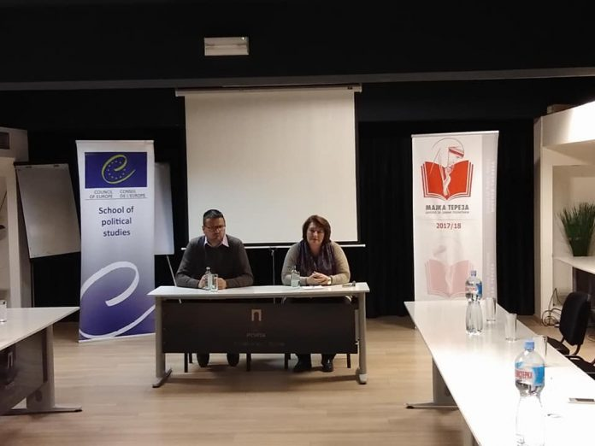

154. Lecture: Geopolitics of the Eastern Mediterranean and Macedonia
Speaker: Jovan Donev, professor and former ambassador
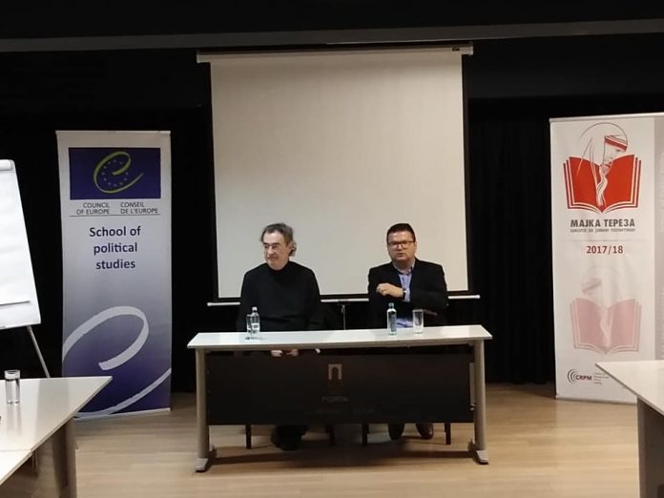

155. Lecture: "Development of Personal Leadership Skills"
Speaker: Jean Stanoevski, Balkan Net, Leadership Academy of Southeast Europe
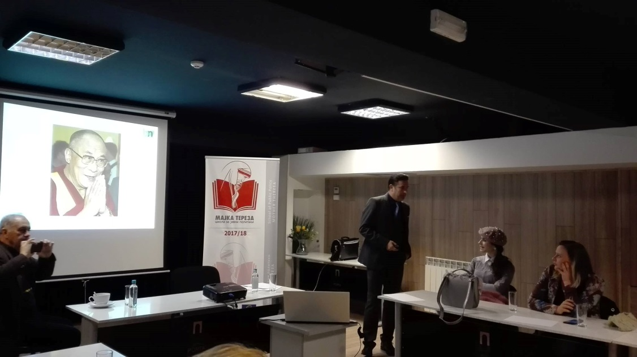

156. Lecture: Strategy for Reform of the Juridical and Political System of Macedonia
Speaker: Miodrag Labovic, Prof., Faculty of Security
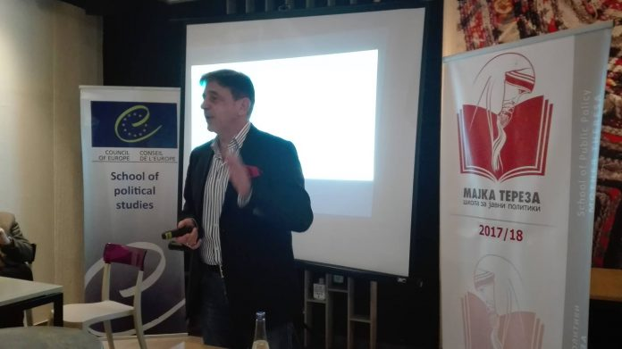

157. Lecture: Public Sector Employment engagement as a basis for more effective policy making Speaker: Neda Maleska Sachmaroska, Executive Director of Center for Management of Change/Центар за управување со промени (ЦУП)
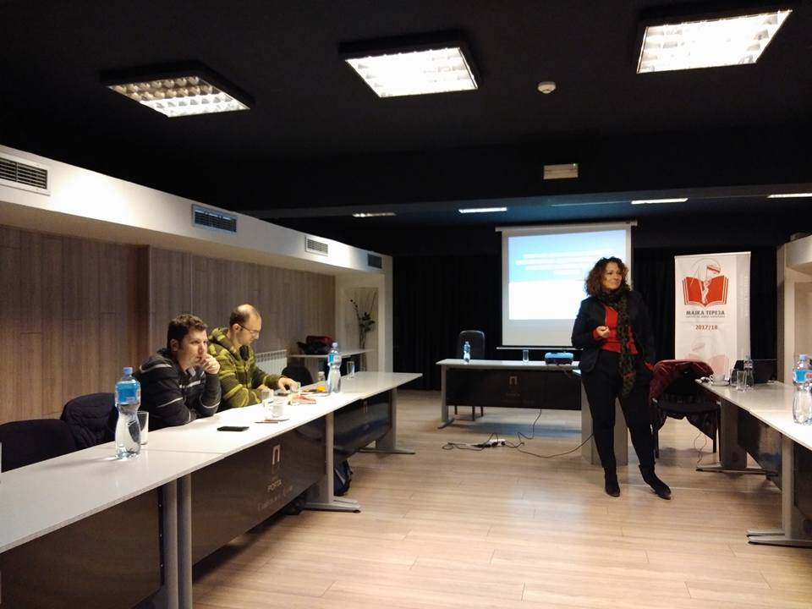
158. Lecture: Macedonia: current challenges and opportunities.
Speaker: Meto Koloski, President of United Macedonian Diaspora.
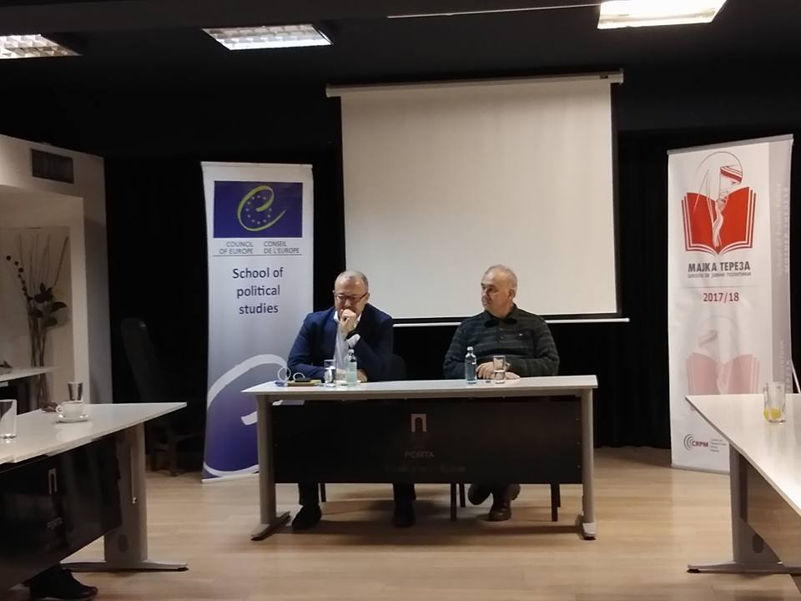

159. Lecture: Tax policies in the Republic of Macedonia
Speaker: Prof. Predrag Trpeski, Faculty of Economics, UKIM
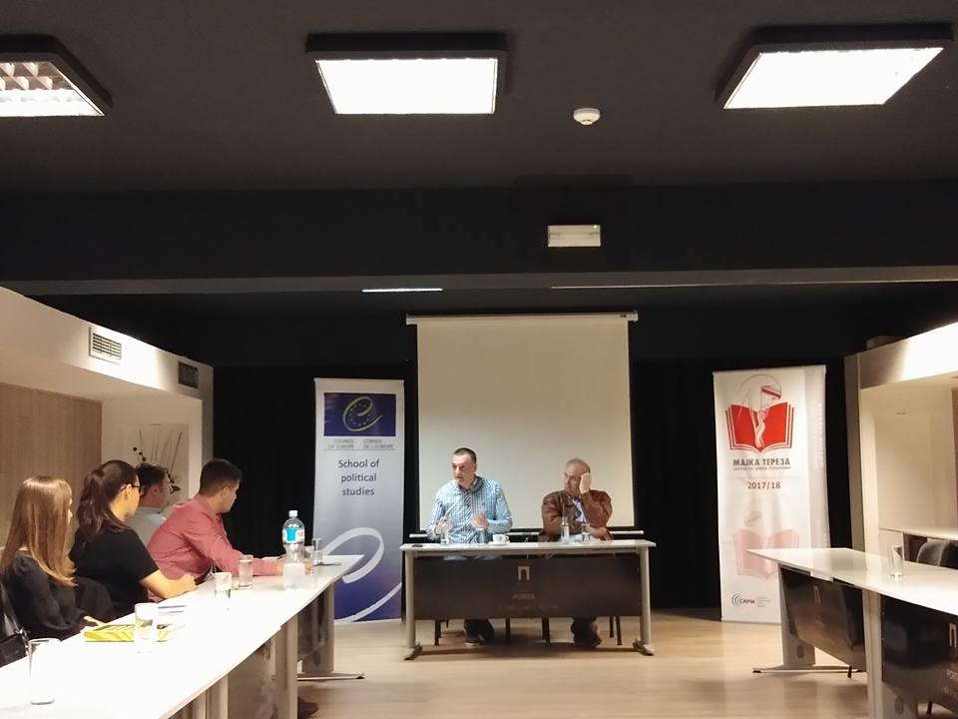

160. Lecture: Fake news and Public Policy
Speaker: Sead Dzhigal, Center for New Media
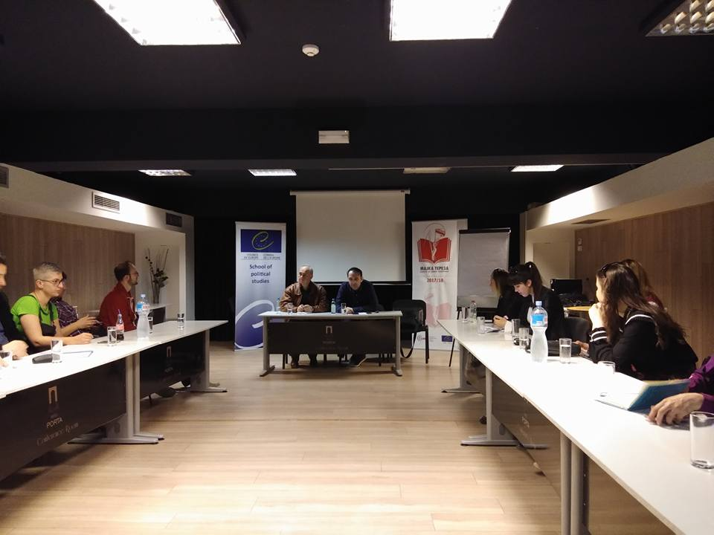
161. Lecture: „Challenges on the Road to Increased Energy Efficiency and Health Environment.
Speaker: Zlatko Simonovski, CRPM
