SCHOOL OF PUBLIC POLICY |MOTHER TERESA| INDIVIDUAL LECTURES AND DEBATES
Period: September 2017 – June 2018

142. Lecture: "Challenges and Opportunities in policy making in Macedonia"
Speaker: Prof. Biljana Vankovska

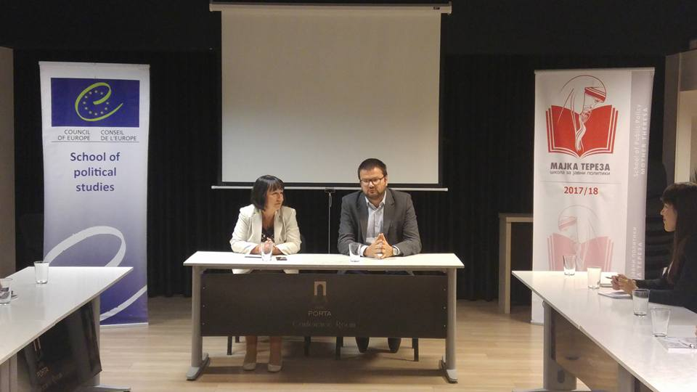

143. Lecture: "EU and the democratic challenges for policy making in the Balkan region"
Speaker: Nicola Bertolini, Head of Cooperation, Delegation of the European Union in Macedonia

